VEMBANAD POST FLOOD FISH COUNT 2018
REPORT

Submitted to

STATE WETLAND AUTHORITY, KERALA

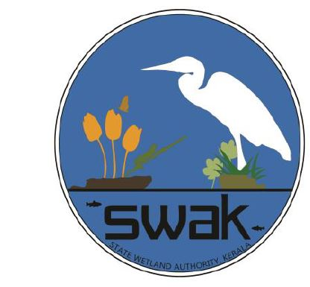

Submitted By

Community Environmental Resource Centre (CERC)
Ashoka Trust for Research in Ecology and the Environment (ATREE)
Ammankovil Street, Mullackal, Alappuzha 688001
PH: 0477-2251818
www.vembanad.org
Email: cerc@atree.org

Contents
Vembanad Post Flood Fish Count 5
Objectives 6
Study Area 6
Methodology 7
Fig 1: Cruise Map (South) 9
Fig 1: Cruise Map (North) 10
Experimental Fishing 11
Inventory made from Fishers 11
Inventory made from Landing-centers 11
Water Quality Parameters 12
Onsite: 12
Offsite: 13
Vembanad Post Flood Fish Count – 2018 Report 15
Results and Discussion 15
Pre-flood 15
Floods 16
Post Flood 16
Suggestions 18
Reference 20
Annexure – 1 (List) 23
Fin-Fish Species List of VFC – 2018 23
Annexure – 2 (Market stock log survey) 27
Annexure – 3 (Followup Market survey) 30
Annexure – 4 (Water quality) 36
Annexure – 5 (Photos) 38
Annexure-6 (Press report)…………………………………………………………………………… 39

Background

Vembanad Lake (Alappuzha, Kerala) and its associated wetlands is the largest tropical wetland ecosystem on the south-west coast of India, covering an area of 1,512 km² (Ramsar, 2002) and has been designated as a Ramsar site, a wetland of global importance for its biodiversity values. Four rivers - Pampa, Meenachil, Achankovil and Manimala, originates from the Western Ghats confluence to the southern portion of Vembanad bringing the water and rich sediments and draining into the Arabian sea (Padmalal et al. 2008), thus making Vembanad the “inland fish basket” of Kerala(Padmakumar 2003; Mayaja & Srinivasa 2014). The lake is considered to be the largest fishery production unit in the south-western coast of India after the Arabian Sea. Vembanad Lake is not only home to large number of fishes but also to numerous migratory and resident birds (Kumar, 2006; S. P. Narayanan, Thomas, & Sreekumar, 2011).
Since the commissioning of Thanneermukkom barrage there has been a drastic decline in the diversity and population of fishes( Kurup & Samuel, 1985; Kurup, et al. 1993; Padmakumar, 2003). Fishery sector is one sector that has been affected adversely due to the commissioning of Thanneermukkom barrage. The annual landing of fish from the Vembanad Lake is down from about 16,000 tonnes a year in the late seventies to about 7,200 tonnes in 2000 (Unnithan, Bijoy, & Vava, 2001). Kurup et al. (1993) have reported reductions in the marine fish and prawn migration to the lake for breeding. Although the use of fishing gear leads to mass destruction and the premature catching of inland fish are legally banned, such practices continue out of livelihood needs (CERC ATREE, 2013). Even though many of the studies (Kannan 1979; Kurup & Samuel 1985; Laxmilatha & Appukuttan 2002; Krishna Kumar &Rajan 2012) have pointed out the decline in fishery resources, still the government hasn’t taken any major efforts to revive the fishery.
In this existing scenario, Kerala has faced its worst floods in 94 years on August 2018 and is still crawling to normality from its aftermath. Land-slides, land-slips, course change in river flow, etc. severely affected almost all topographic levels of land area which included highland, midland, and lowland. Several organisms in the higher altitudes and from the aquaculture farms got displaced in this course, and many had to face sad demise due to anthropogenic as well as miscellaneous reasons, especially reptiles and fishes. Displacement of fishes during floods from a higher altitude to a lower level is a global reality, and in the case of Vembanad as well, it was no different. The need for this study had been set as fisher folks in the area started coming across exotic fishes in the estuary which was not common in the open and too in very huge amounts. As the discovered ones were freshwater species and also as Vembanad did possess certain areas with freshwater logging at least in some part of every year, the existence of the exotics posed the question of the species’ chance of acclimatization and procreation in the system, which might prove fatal for the native species if invaded. In this background ATREE CERC proposed a post flood fish count to assess the fish stock diversity in Vembanad wetlands. The project was supported by the State Wetland Authority, Kerala (SWAK).

Vembanad Post Flood Fish Count
Ashoka Trust for Research in Ecology and the Environment (ATREE) initiated the Vembanad Fish Count (VFC) as an annual participatory fish assessment in May 2008 to understand the fishery and ecological trends in Vembanad. Several institutions and agencies like the Kerala State Biodiversity Board, Department of Fisheries, Department of Environment and Climate Change, Government of Kerala., Vembanad Nature Club, and Vembanad Lake Protection Forums are the co -organizers of the event. Kerala University of Fisheries and Ocean Sciences (KUFOS, erstwhile Fisheries College, Panangad) is providing the necessary technical support for the event. Vembanad Fish Count is a democratic approach in resource monitoring which is different from the conventional top-down approaches. It is a stakeholder driven program where the targeted groups participate in the entire process, learning about the situation, identifying problems, discussing alternatives, seeking solutions, designing and implementing activities, evaluating and disseminating results. In this process, fisher folk of Vembanad share their traditional knowledge to identify problems and solutions, ensuring that the poor and uninformed will not be excluded from decision-making and development opportunities. Such dialogue initiated during the VFC has lead the fisher community here to organize as Lake Protection Forum(LPF). 14 units of LPFs are now registered and are federated as Federation of Lake Protection Forums. LPFs are taking a leading role in organizing several conservation programs at Vembanad. One of the important activities of LPFs is the Matsyathaavalam (fish sanctuaries). Fisher folk have created 23 fish sanctuaries (no-fishing area with breeding supports for fishes) based on their traditional knowledge.
VFC brings together researchers, NGOs, environmentalists, students and media from Southern India. Fishers, local-self-governments, schools from around the lake are participating in this annual event and are very eager to learn about the status of fishery resources of the lake. This event has helped to consolidate views on the issues and convinced the need for immediate interventions in this sector, especially through participation of the stakeholders. The program consists of two modules; namely action &awareness.

Vembanad Post Flood Fish Count – 2018, in addition to 11th edition of its former (VFC) was carried out in three major steps this time rather than two from previous years; viz., a participatory workshop, fish count in south of Thanneermukkom bund and north of Thanneermukkom bund.

Objectives
- To carry out an extensive survey on the fish diversity of the southern and northern sector of Vembanad Lake with special focus on exotics
- Capacity building to focus attention to issues on lake deterioration and biodiversity decline, into public domain.
- To understand how different types of pollution affects the Lake.

Study Area
Vembanad Lake (9° 34’ 60” N, 76° 25’ 0” E), a transitional ecotone between sea and land is the largest humid tropical wetland on the west coast of India with a length of 96 km and a surface area of 252km². Seven rivers which originate from the Western Ghats Biodiversity Hotspot drain to the lake and eventually join the Arabian Sea. The rich biodiversity and socio economic importance, of Vembanad lake along with adjacent Kole-lands led to the declaration of the lake as a Ramsar site; a wetland of international importance. The mangrove patches and islands in the lake like Pathiramanal also provide habitat for resident and seasonal migratory water fowl, otters, fish, clams, shrimps, crabs, aquatic insects and other aquatic organisms. The lake is also renowned for its live clam resources and sub-fossil shell deposits, large populations of water fowls, besides a high species diversity of finfish and shellfish (WWF 2002). (WWF, 2002). One hundred and fifty species of fishes belonging to hundred genera and fifty-six families are known to occur in Vembanad Lake (Kurup and Samuel,1985). The list also includes vulnerable species such as Horabagrus brachysoma, Carinotetraodon travancoricus (Molur and Walker 2001). The Thanneermukkom Salt Water Barrage divides the lake into two parts – the perennial brackish water part on the North and the southern freshwater fed by the rivers draining into the lake with seasonal salt water intrusion from high tide during non-rainy seasons. These freshwater regions of the lake are facing ecological problems due to rampant propagations of water hyacinths and eutrophication. Unmanaged and unregulated tourism and unethical fishery practices are also posing serious threats to the Vembanad Lake. (Krishnakumar et. al., 2007).

Methodology
With ninety volunteers from local stakeholders, various colleges, Universities, research institutes and Non-Governmental Agencies participated in Vembanad post flood fish count 2018. The entire team was divided into three cruise groups for both days.
Day 1: The Kumarakom Cruise (East Bank), Kuttanad (Riverine Sector) Cruise and Pathiramanal Cruise (West Bank) with 35 -40 members in each team.
Day 2: The Murinjapuzha cruise, Arookutty cruise and High court cruise.
Each cruise team was further subdivided into four in order to assign responsibilities for
1) Experimental fishing,
2) Collecting data from landing centers,
3) Collecting data from fishers in the lake and
4) Water quality monitoring. The cruise teams conducted experiments at 15 (5X3) previously identified sampling points.

Day 1:
Murinjapuzha Cruise | Arookutty Cruise | High court Cruise
Murinjapuzha | Arookutty | High court
Achanthuruthu | Aroor | Vaduthala
Manappuram | Kumbalam | Kothad
Vaikom | Edakochi | Blayikadavu
Pallippuram | Valathakkadu | Kadamakudy
T V Puram |  | Manjanakad

Day 2:
East Bank cruise | West Bank cruise | ‘Riverine cruise
Ambika Market | Kayippuram, | Punnamada
Kumarakom | Pathiramanal, | Chungam
Nazreth | Muhamma, | Kainakary,
Chithira Kayal | Mannancheri | Aarayiram Kayal
R Block. | Aryad | Sai

The program commenced from 6am and extended till 3pm on 22nd December 2018 and 6 am to 5:30pm on 23rd December 2018.
A week before the survey, an expert team of fish taxonomists explored around the lake for fish landing center inventory and collected the data from Vaikom and Pallom landing center’s during the early morning hours. In addition to this on the day of fish count Ambika Market located near Thanneermukkom bund and Punnamada landing center respectively was also surveyed in the morning by students and experts.
As part of capacity building an orientation workshop (participatory workshop) was arranged on the day before fish count in order to capacitate the participants on their duties and responsibilities and etiquettes to be followed during fish count. A fish identification guide, water quality analysis and collection kit along with GPS were provided to carry out the exercise.

Fig 1: Cruise Map (South)
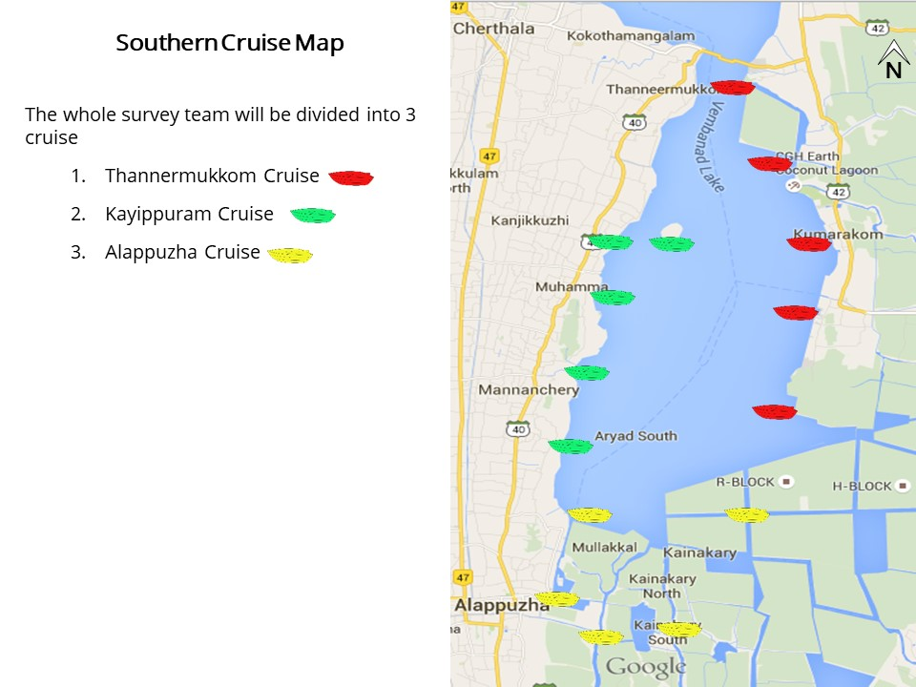

Fig 1: Cruise Map (North)
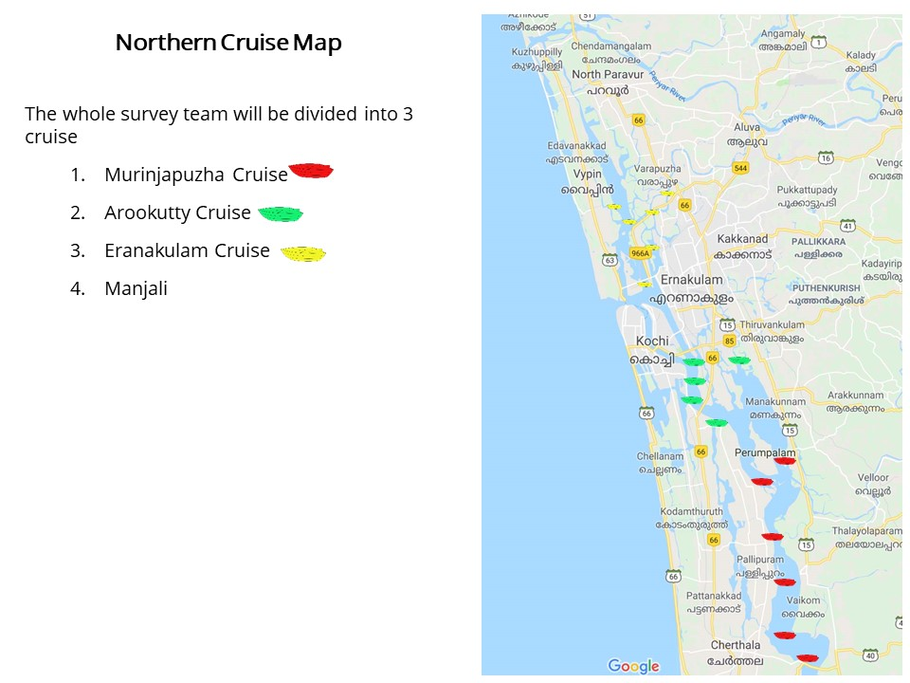

Experimental Fishing
This was facilitated with the help of local fishers who accompanied the cruise at all different stations using three major fishing gears, namely;
- Gill Net: One gill net each was laid at six locations; i.e., at two sites for each cruise. The nets were laid by around 2am and was retrieved by 6am. The collection was ice preserved till each team arrived for inspection. All entries were made on to the survey forms distributed to the participants
- Cast Net: Cast net was thrown at five points each at all five sites of each cruise (total = 5X5X3). Entries were made as mentioned above. The specimens obtained were either left back after successful identification and counting or collected in alcohol/formalin depending upon the use to be carried out later on. Alcohol preservation was preferred in case of DNA analysis and formalin in case of further morphological lab examination.
- Scoop Net: Scoop net was also carried out five times at each at all five sites of each cruise and the following activities were done as the same as above.
The abundance (number of individuals at each sampling point) and diversity (type of each species) data had been recorded on the respective survey forms provided to the participants. An additional replicate data was also collected this year in order to maintain track of the number of individuals obtained per each netting.

Inventory made from Fishers
This was carried out with the due participation of local fishers who allowed us to check the species, which contributed to their catch on the count day. Enquiries were also made on the fishing methods and socio-economic information of the fishers. The obtained information was recorded to the respective survey forms.

Inventory made from Landing-centers
The major landing centers around the sampling sites viz. Punnamada, Pallom and Vaikom were visited on the two consecutive days prior to fish count and the species diversity were recorded. The type of gear used and the percentage of commercially important fishes to the catches were recorded in consultation with the fishers.

Water Quality Parameters
Water quality parameters were tested onsite as well as offsite.

Onsite:
- pH: pH is a numeric scale used to specify the acidity or basicity of an aqueous solution. pH was measured using standard pH solution marketed by C.P.R. Environmental Education Centre, Chennai (CPREC). Water samples were collected and analyzed 3 times each to arrive at concordant values. In addition, samples were also taken aboard for confirmatory lab analysis.
- Transparency: Transparency of water relates to the depth that light penetrates water. As light penetrates water, it becomes attenuated and altered in its spectral composition. The change that occurs is from predominantly yellow light at the surface to blue-green at depth in clear water or yellow-green in waters having a high concentration of dissolved organic material. Secchi disk is a simple device used to measure the transparency of water bodies. Water clarity is related to amounts of suspended particles (turbidity) as well as amounts of phytoplankton and zooplankton. Seechi readings were carried out at all sites and valued were recorded on to survey forms.
- Temperature (atmospheric/water): Temperature exerts a major influence on the biological activity and growth of aquatic organisms. Both water and atmospheric temperatures were measured at all sites using alcohol based laboratory thermometers. Results were recorded on to survey forms.
- Salinity: Salinity is the amount of dissolved salt substance of the water. Salts are compounds like sodium chloride, magnesium sulfate, potassium nitrate, and sodium bicarbonate which dissolve into ions. Salinity was measured at all sites using a salinometer and the readings were recorded on to survey forms.
Offsite: Water samples were collected in 500ml water bottles to be analyzed at Kerala State Pollution Control Board (KSPCB) affiliated labs. Water samples for estimation of dissolved oxygen was fixed in field using Winkler A and B respectively after which all samples where preserved in ice boxes.
- Total Hardness: Total hardness is defined as the sum of calcium and magnesium hardness (Even though Fe²⁺, Fe³⁺, Sr²⁺, Zn²⁺, and Mn²⁺ may contribute to water hardness, their levels are typically much less than Ca²⁺ and Mg²⁺. Their levels are not usually included in total hardness measurements) in mg/L as CaCO₃. Ideal quality water should not contain more than 80 mg/L of total hardness as CaCO3. (Vernier).
- Dissolved Oxygen (DO): Dissolved oxygen (DO) is the amount of oxygen that is present in the water. It is measured in milligrams per liter (mg/L), or the number of milligrams of oxygen dissolved in a liter of water. Samples to be analyzed was collected using Winkler method.
- Nitrate: Presence of nitrate in lakes could be from agriculture run-off waters as fertilizers are considerably made of nitrate owing to its high solubility and biodegradability. (Laue et al., 2006). Presence of normal levels of nitrates usually does not have a direct effect on aquatic organisms. Algae and other plants use nitrates as a source of food. If algae have an unlimited source of nitrates, their growth is unchecked. This could lead to “Eutrophication”, anoxia to lake conditions etc. Levels exceeding 50 mg/L (ppm) nitrate-nitrogen are considered unhealthy for lakes.
- Nitrite: Nitrites occur in water as an intermediate product in the biological breakdown of organic nitrogen, being produced either through the oxidation of ammonia or the reduction of nitrate. The presence of large quantities of nitrites is indicative of waste water pollution. Levels exceeding 0.55 mg/L (ppm) nitrite-nitrogen can cause 'brown-blood' disease in finfish.
- Iron: Concentrations above 1 mg/L will impart a foul taste to the water. High concentrations can indicate runoff from mining operations or industrial effluent and indicate the need for further investigation before prescribing a treatment regimen. Proper lake water limit levels are unavailable.
- Phosphate: High phosphate concentrations in surface waters may indicate fertilizer runoff, domestic waste discharge, or the presence of industrial effluents or detergents. If high phosphate levels persist, algae and other aquatic life will flourish, eventually decreasing the level of dissolved oxygen due to the accelerated decay of organic matter. Algae blooms are encouraged by levels of phosphate greater than 25 micrograms/L.
- Others: Magnesium, Calcium and Sulphate were the other measured parameters.
Orientation Workshop
Orientation workshop for the participants was conducted on 21st December 2018 at KUFOS at 6 pm. Shri. Jojo T. D (Project Coordinator, ATREE-CERC) delivered the welcome address. Dr. Priyadarsanan Dharma Rajan (Senior Fellow, ATREE-Bangalore) chaired the inaugural session. Dr. Rajeev Raghavan (Asst. Professor, KUFOS), inaugurated the function. The orientation for 90 volunteers of Vembanad fish count was given by Mr. Anu Radhakrishnan (Research Associate, ATREE-Bangalore) where he discussed a brief history of Vembanad and CERC’s activities, and the objectives of Vembanad Fish Count. Methodology used for data collection and the basic etiquettes and discipline/safety measures to be followed during the cruise. Participants for the program were divided into three teams for both days. For each team, a cruise leader was selected, who were assigned the task of making the organizational groups and functional groups for effective conduct of the survey. Fishing gears, resource materials and survey forms were distributed to each team before dispersing for dinner. The three designated teams for day 1 were Murinjapuzha cruise (starting from Murinjapuzha0, Aroorkutty cruise (starting from Arookutty market) and High court cruise (staring from high court area). For day 2, East bank (Starting from Kumarakom), West Bank (Kayippuram) and Riverine (Starting from Alappuzha). Mr. Anu Radhakrishnan (Research Associate, ATREE-Bangalore), Dr. Anwar Ali (Asst. Professor, KUFOS) and Dr. Rajeev Raghavan (Asst. Professor, KUFOS) were the resource persons for all three cruises both days.

Vembanad Post Flood Fish Count – 2018 Report
On 22nd December, Fish Count was flagged off by Dr. Rajeev Raghavan (Asst. Professor, KUFOS), Ernakulam high court; the high court cruise started from this point. The other starting point were Murinjapuzha and Arookutty.
The cruise boats moved towards each sites where the team halted for approximately 35-45mins and conducted experimental fishing with the help of different gears; viz. gill net, cast net and scoop net. Onsite water quality data and water for offsite analysis were also collected along with data pertaining to fish habitats including primary visual data. The team members of each cruise also discussed and compiled the data collected, to make a rough presentation in the concluding session.
All teams returned to the KUFOS, after day 1 and to ATREE-CERC Alappuzha after day 2. The collectibles and data were compiled together to provide with the necessary conclusions.

Results and Discussion
Prior to Vembanad post flood fish count, in the month of May 2018, Vembanad fish count had been conducted. The results henceforth shall be provided in three sub-heads.

Pre-flood
Vembanad fish count 2018, unlike its previous version had been different as it was the first time it got extended from south of Vembanad to north. The exercise recorded 97 fin-fish species and 10 shell fish species. The count had even coverage of species as it recorded the largest available species Channa diplogramma, Caranx ignobilis etc. and smallest species like Oryzias setnai, Horadandia brittani etc. Though the total number of species recorded from Vembanad counts upto 183 fin-fishes till date, however fish count 2018 recorded only 97 of them, the rest could be unavailable either because of seasonal variations or locally extinct situations. Since, habitat destruction happens on a rapid pace in Vembanad, fishes might have also migrated out of the system in search of better refugee space. Species list has been provided as Annex. 1

Floods
Kerala floods 2018 was the second of its kind hitting Kerala after 94 years since it’s former made a scar. The floods were totally devastating across all elevations in Kerala; viz., highland, midlands and lowlands. Vembanad had to take the load especially since all the major rivers draining into it had drained all the contained into the lake. The interesting attraction was the displacement of pure exotics (neither native to India or Vembanad) fishes and Indian exotic fishes (native to India but not Vembanad) from higher altitudes to Vembanad. A plethora of fish diversity was recorded from the lake, just after floods especially commercially valuable ones. Details of various fishes availed with weight has been provided as Annex. 2. There had been a skyrocketing of pure exotics since floods. But plummeted soon after 3-4 weeks. Even though the primary reason was displacement of the same from higher altitudes. The species seen, Piaractus brachypomus, Pangasius sps., and Clarias garipienus are illegally farmed fishes in dams, reservoirs and private farms. Portraying poor quarantine systems in India, despite strong CBD (Conservation of Biological Diversity) norms. Since, the plummeting happened, it was considered that the species are not resilient enough to survive in the system. But follow up surveys proved them wrong. Details in post flood.

Post Flood
Post flood fish count reported 106 fin-fish species, 10 shell fish species and 1 mollusc species. An addition of 4 species had been mainly due to seasonal variations, however the rest five were the exotics reported during flood. Even though all these exotics had been before also from markets near Vembanad, it had never been reported from the wild. Since, there are small number of cage cultures and private farms near Vembanad especially at the upper reaches of the lake, all these species found a market before hand in the markets around the system, but since controlled was never a topic of discussion. The post flood fish count only recorded the exotics on a very lesser count ranging across the system to 4-5kgs per market to a maximum of 40kgs across the system. Further market survey however showed a different trend. A detailed market survey conducted in March 2019 reported all the exotics again from the wild especially Pangasius sps. ranging between 100-250kg per market on a weekly basis from the wild. This shocking record has to be noted with caution. As Pangasius sps is omnivorous, indigenous species shall have to fight predation as well as competition to withstand the pressure for its survival. Unfortunately, this situation is highly unlikely to happen and more chances are the exotics might flourish. Details of market survey provided as Annex 3. It is high time that different stakeholders take a decision on this call and take necessary steps such that the natural resources are conserved in this system.

Suggestions

● The state and central Governments should put efforts to sustain the fisheries sector through a holistic approach which includes habitat protection, enforcement of regulations and adoption of co-management strategies. This will lead to improving the livelihoods of fishers and avoiding further degradation and deterioration of habitat quality of the ecosystem.
● Regular Fish survey and water quality analysis should be conducted during all three seasons viz. Monsoon (June-August), Post-Monsoon (October-November) and Pre-Monsoon (March-April) may be carried out for at least 3 years to make better estimation on fish diversity and ecosystem health of the lake. Long term monitoring mechanism on population dynamics of various fish species which are thought to be declining and study the effect of Thanneermukkom Bund on migratory fishes Vembanad should be taken up through collaborative projects involving various research organizations.
● Develop an Index for lake conservation like Index of Biotic Integrity (IBI) for Vembanad Lake ecosystem (standards for water quality and the organisms inhabiting the lake indicating ecosystem health) and regular monitoring to ensure its sustainable health.
● Awareness programs should be conducted within the community inhabiting around the lake and tourists visiting the ecosystem regarding its global importance in sustainable living and existence of all living organisms and the bigger role it could play in mitigating global climate change and ecological vulnerability if developed as a conservation model.
● Whenever wherever possible undisturbed areas of Vembanad Lake/Kole should be maintained as such to retain its pristine nature to set itself as control and scale up the health levels of the rest of the areas to a standard point possible.
● Strict pollution control policies should be developed and implemented in compliance with Wetland and Paddy Conservation Act 2008.
● A strict fishing policy should be formulated by analyzing various methods currently used in the ecosystem so that only the most sustainable ones are selected for practice in lake.
● Existing natural habitats and native vegetation like those surrounding Pathiramanal islands, the reclaimed portions of lake at Chithira and Rani Block of kayals should be declared as No Take Zones.
● Develop breeding and hatchery protocols for fishes that are used in ranching and stock enhancements.
● Measures should be taken to protect riparian and indigenous macrophytes inhabiting the lake.
● Ban monsoon flood plain fishery (Ootha piditham) when spawning individuals are largely targeted.
● stablishing a democratic-management system should be a top priority for fisheries planners in the Vembanad. This should be based on a bottom-up strategy rather than the conventional top-down schemes which have been a failure.
● Collaborations between various central and state government organizations, research institutes, universities, colleges, non-governmental organizations and cooperatives with due participation of local stake holders should be made and efficient programs for protecting the lake, its resources and the livelihoods of the fishers depending on the ecosystem should be adapted.
● Municipal drains should empty to the lake only after proper treatments and the water disposed henceforth should meet the ideal standards of estuarine lake water or freshwater system.
- Revisit India’s quarantine policies and revamp in such a manner that illegal fish or for that matter any kinds of species exotic in nature to India or that specific land area shall be strictly controlled so as to prevent any outbreak that might result in future.
- Handy books or field guides to identify already available exotics species in different landscapes of India, especially that Vembanad should be prepared so that layman could also be advised about alarming situations in systems.

Reference
● Asha, C. V, Cleetus, R. I., Suson, P. S., & Nandan, S. B. (2015). Environmental factors structuring the Fish assemblage distribution and Production potential in Vembanad estuarine system, India. International Journal of Marine Science, 5.
●Bates, Roger G. Determination of pH: theory and practice. Wiley, 1973.
●CERC ATREE. (2013). Participatory Mapping of Natural Resources in Vembanad Lake. Retrieved from www.vembanad.org
●Commission, P. (2008). Report on Visit to Vembanad Kol, Kerala, a Wetland Included Under the National Wetland Conservation and Management Programme of the Ministry of Environment and Forests. Retrieved from http://203.200.22.249:8080/jspui/handle/123456789/4074.
●Dunbar, Jeffery A (2001) Casting net NC Coastal fishing. Retrieved 25 August 2008.
●Florence, M. A. (2012). Sustainability and livelihood issues of Vembanad Ecosystem fisherfolk communities with special reference to Muhamma and Thanneermukkom villages.
●Fondriest Environmental, Inc. “Dissolved Oxygen.” Fundamentals of Environmental Measurements. 19 Nov. 2013. Web. <http://www.fondriest.com/environmental-measurements/parameters/water-quality/dissolved-oxygen/>
●Geetha, R., Chandramohankumar, N., & Mathews, L. (2007). Distribution of total reactive fluoride in sediments of Kuttanad waters. INDIAN JOURNAL OF ENVIRONMENTAL PROTECTION, 27(11), 1001.
●Hedley, M. J., Stewart, J. W. B., & Chauhan, B. (1982). Changes in inorganic and organic soil phosphorus fractions induced by cultivation practices and by laboratory incubations. Soil Science Society of America Journal, 46(5), 970-976.
●Kannan, K. (1979). Ecological and socio-economic consequences of water-control projects in the Kuttanad region of Kerala. Proceedings of the Indian Academy of Sciences Section C: Engineering Sciences, 2(4), 417–433.
●Kannan, K. P. (1979). Ecological and socio-economic consequences of water-control projects in the Kuttanad region of Kerala. Proceedings of the Indian Academy of Sciences Section C: Engineering Sciences, 2(4), 417–433.
●KrishnaKumar, K., & Dharmarajan, P. (2012). Fish and Fisheries in Vembanad Lake Consolidated Report of Vemband Fish Count 2008-2011.
●Kumar, A. B. (2006). A checklist of avifauna of the Bharathapuzha river basin, Kerala. Zoo Print, 21(8), 2350–2355.
●Kurup, B., & Harikrishnan, M. (2000). Reviving the Macrobrachium rosenbergii (de Man) fishery in Vembanad lake, India. Naga, The ICLARM Quarterly, 23(2), 4–9.
●Kurup, B. M., & Samuel, C. T. (1985). Fish and fishery resources of Vembanad Lake. Harvest and Post-Harvest Technology of Fishes. Central Institute of Fisheries Technology (CIFT) &Society of Fisheries Technologists (SOFTI), Kochi, India, 77–82.
●Kurup, B. M., Sebastian, M. J., Sankaran, T. M., & Rabindranath, P. (1993). Exploited fishery resources of the Vembanad Lake. Indian Journal of Fisheries, 40(4), 199–206.
●Laxmilatha, P., & Appukuttan, K. K. (2002). A review of the black clam (Villorita cyprinoides) fishery of the Vembanad Lake. Indian Journal of Fisheries, 49(1), 85–92.
●M.S. Swaminathan Research, F. (2007). Measures to Mitigate Agrarian Distress in Alappuzha and Kuttanad Wetland Ecosystem.
●Manorama, K. C., & Agricultural, K. (n.d.). Nature Watch.
●Mayaja, N. A., & Srinivasa, C. V. (2014). Rainfall characteristics of Pampa river basin, Kerala: A time series analysis.
●Michaud, J.P. 1991. A citizen's guide to understanding and monitoring lakes and streams. Publ. #94-149. Washington State Dept. of Ecology, Publications Office, Olympia, WA, USA (360) 407-7472. Moore, M.L. 1989.
●Murphy, B. R., & Willis, D. W. (Eds.). (1996). Fisheries techniques (2nd ed., p. 732). Bethesda, Maryland: American fisheries society.
●Narayanan, N. C. (2003). Against the grain: the political ecology of land use in a Kerala region, India.
●Narayanan, S. P., Thomas, A. P., & Sreekumar, B. (2011). Ornithofauna and its conservation in the Kuttanad wetlands, southern portion of Vembanad-Kole Ramsar site, India. Journal of Threatened Taxa, 3(4), 1663–1676.
●Padmakumar, K. G. (2003). Open water fish sanctuaries. Kerala Calling, 23(6), 34–36.
●Padmalal, D., Maya, K., Sreebha, S., & Sreeja, R. (2008). Environmental effects of river sand mining: a case from the river catchments of Vembanad lake, Southwest coast of India. Environmental Geology, 54(4), 879–889.
●Ramsar. (2002). VEMBANAD-KOL WETLAND. Retrieved from https://rsis.ramsar.org/ris/1214
●Samuel, C. T. (2014). Studies on systematic and biology of the fishes of Vemabanad lake.
●Sathyanathan, N. (2010). Overview of farming practices in the water-logged areas of Kerala, India. International Journal of Agricultural and Biological Engineering, 3(4), 28–43.
●Suseelan, C. (1987). Impact of environmental changes and human interference on the prawn fishery resources. Marine Fisheries Information Service, Technical and Extension Series, 73, 1–5.
●Unnithan, V. K., Bijoy, N. S., & Vava, C. K. (2001). Ecology and fisheries investigations in Vembanad Lake. CICFRI Bull, (107).
●Wolfgang Laue, Michael Thiemann, Erich Scheibler, Karl Wilhelm Wiegand "Nitrates and Nitrites" in Ullmann's Encyclopedia of Industrial Chemistry, 2006, Wiley-VCH, Weinheim.
http://www.alken-murray.com/

Annexure – 1 (List)

Fin-Fish Species List of VFC – 2018
South of Thannermukkom Bund | North of Thannermukkom Bund
- Ambassis ambassis | - Ambassis ambassis
- Ambassis gymnocephalus | - Anodontostoma chacunda
- Amblypharyngodon melettinus | - Arius arius
- Anabas testudineus | - Arius maculatus
- Anodontostoma chacunda | - Arius subrostratus
- Aplocheilus blochii | - Brachirus orientalis
- Aplocheilus panchax | - Butis butis
- Arius subrostratus | - Caranx sexfasciatus
- Brachirus orientalis | - Caranx sps 2
- Caranx ignobilis | - Caranx sps.
- Carinotetraodon travancoricus | - Chanos chanos
- Channa diplogramma | - Chelonodontops patoca
- Channa pseudomarulius | - Colichthys dussumieri
- Channa striata | - Congersox talabonoides
- Chelonodontops patoca | - Crenimugil seheli
- Cynogolossus macrostomus | - Cynoglossus cynoglossus
- Dawkinsia filamentosa | - Dyascinia albida
- Dayella malabarica | - Ehirava fluviatilis
- Etroplus suratensis | - Elops machnata
- Gambussia affinis | - Epinephelus
- Glossogobius giuris | - Epinephelus malabaricus
- Heteropneustes fossilis | - Epinephelus tauvina
- Horadandia britani | - Gaza minuta
- Oryzias setnai | - Gerres filamentosus
- Horbagrus brachysoma | - Gerres setifer
- Hyporamphus xanthopterus | - Grammoplite scaber
- Labeo dussumieri | - Grassostria madrasensis
- Macrognathus guentheri | - Hyporamphus limbatus
- Mystus armatus | - Johnius dussumieri
- Mystus gulio | - Lates calcarifer
- Mystus occulatus | - Liza parsia
- Neochela dadyburjori | - Liza subvirdis
- Parambassis dayi | - Lutjanus argentimaculatus
- Parambassis thomassi | - Megalops cyprinoides
- Photopectoralis bindus | - Minodactylus argentius
- Pseudetroplus maculatus | - Mugil cephalus
- Pseudosphromenus cupanus | - Nematlosa nasus
- Pseudosphromenus dayi | - Nuchequlla manuella
- Puntius amphibius | - Nuchequlla nuchalis
- Puntius parrah | - Oreochromis mossambicus
- Puntius vittatus | - Oxyurichthys microlepis
- Scatophagus argus | - Photopectoralis bindus
- Siganus javus | - Platycephalus indicus
- Stenogobius sps. | - Pseudorhombus arsius
- Systous sarana | - Scatophagus argus
- Xenentodon cancila | - Siganus canaliculatus
 | - Siganus javus
 | - Siganus sps
 | - Sillago sihama
 | - Sphrynae jello
 | - Stolephorus indicus
 | - Stolephorus sps
 | - Terapon jarbua
 | - Tetraodontidae
 | - Thryssa hamiltoni
 | - Thryssa malabarica
 | - Trachinotus blochii
 | - Trypauchen vagina
Species recorded from the Landing Centre Pallom
PALLOM
Sl No | FIN FISHES
1 | Mystus gulio (Hamilton 1822)
2 | Channa marulius (Hamilton 1822)
3 | Pseudetroplus maculatus(Bloch 1795)
4 | Channa striata (Bloch 1793)
5 | Channa diplogramma (Day, 1865)
6 | Heteropneustes fossilis (Bloch 1794)
7 | Labeo dussumieri (Valenciennes 1842)
8 | Macrognathus guentheri (Day 1865)
9 | Systomus sarana (Hamilton 1822)
10 | Megalops cyprinoides (Broussonet 1782)
11 | Horabagrus brachysoma (Günther 1864)
12 | Mystus armatus (Day 1865)
13 | Hyporhamphus xanthopterus (Valenciennes 1847)
14 | Etroplus suratensis (Bloch 1790)
15 | Puntius filamentosus (Valenciennes 1844)

Species recorded from Thanneermukkom Market.
Thanneermukkom Market Survey
SL No | Species
1 | Mystus gulio (Hamilton 1822)
2 | Leiognathus equula (Forsskål 1775)
3 | Channa marulius (Hamilton 1822)
4 | Anabas testudineus (Bloch 1792)
5 | Pseudetroplus maculatus(Bloch 1795)
6 | Thryssa dussumieri (Valenciennes 1848)
7 | Gerres filamentosus Cuvier 1829
8 | Brachirus orientalis (Bloch & Schneider 1801)
9 | Terapon jarbua (Forsskål 1775)
10 | Channa striata (Bloch 1793)
11 | Heteropneustes fossilis (Bloch 1794)
12 | Saurida tumbil (Bloch 1795)
13 | Systomus sarana (Hamilton 1822)
14 | Clarias dussumieri Valenciennes 1840
15 | Puntius filamentosus (Valenciennes 1844)
16 | Macrognathus guentheri (Day 1865)
17 | Horabagrus brachysoma (Günther 1864)
18 | Mystus armatus (Day 1865)
19 | Sillago sihama (Forsskål 1775)
20 | Arius subrostratus Valenciennes 1840
21 | Nematalosa nasus (Bloch 1795)
22 | Siganus javus (Linnaeus 1766)
23 | Anodontostoma chacunda (Hamilton 1822)
24 | Megalops cyprinoides (Broussonet 1782)
25 | Labeo dussumieri (Valenciennes 1842)
26 | Elops machnata (Forsskål 1775)

Annexure – 2 (Market stock log survey)
Species | June (Kg) | July (Kg) | August (Kg) | September (Kg) | October (Kg) | Novermber (Kg)
Ambassidae | 672.8 | 56 | 162 | 30 | 15 | 17
Amblypharyngodon melettinus | 4 | 0 | 0 | 0 | 0 | 26
Anabas testudineus | 145 | 107 | 0 | 0 | 0 | 4
Anguilla | 36 | 40 | 0 | 15 | 7.5 | 5
Brachirus orientalis | 50 | 43 | 17 | 152 | 84.5 | 50
Caranx | 56.3 | 104 | 22 | 855 | 438.5 | 201
Channa diplogramma | 153 | 24 | 0 | 0 | 0 | 2
Channa pseudomarulius | 518 | 82 | 15 | 0 | 7.5 | 3
Channa striata | 373.5 | 72 | 23.4 | 39 | 31.2 | 24
Chanos chanos | 34.7 | 34 | 32 | 167 | 99.5 | 0
Chatti koori | 312 | 80 | 0 | 0 | 0 | 0
Shrimp | 797.9 | 135 | 1386 | 630 | 1008 | 700
Chenkadi | 60 | 39 | 0 | 0 | 0 | 0
Choodan | 540 | 88 | 0 | 0 | 0 | 15
Cynoglossus macrostomus | 472.2 | 520 | 108 | 0 | 54 | 28
Dayella malabarica | 60 | 54 | 21 | 915 | 468 | 250
Etroplus suratensis | 2637.6 | 1018 | 403 | 251 | 327 | 300
Gerres | 15 | 6 | 0 | 42 | 21 | 13
Heteropneustes fossilis | 325.2 | 220 | 0 | 33 | 16.5 | 11
Horabagrus brachysoma | 187 | 118 | 126 | 51 | 88 | 72
Hyporamphus xanthopterus | 2649.8 | 217 | 112 | 89 | 100.5 | 70
Mullet | 167 | 90 | 31 | 94 | 62.5 | 51
Prawn (Small) | 54 | 62 | 102 | 68 | 85 | 55
Koona Chemmen | 0 | 0 | 180 | 118 | 149 | 100
Koori | 282.8 | 215 | 98 | 87 | 92.5 | 76
Koorivala | 0 | 0 | 68 | 112 | 90 | 10
Kuyil | 0 | 0 | 253 | 18 | 135.5 | 110
Labeo catla | 570 | 120 | 62 | 473 | 268 | 193
Labeo dussumieri | 329.2 | 189 | 311 | 504 | 407 | 200
Labeo rohita | 490 | 171 | 78 | 122 | 100 | 50
Lates calcarifer | 75 | 87 | 500 | 312 | 406 | 300
Lutjanus argentimaculatus | 136 | 0 | 0 | 0 | 0 | 30
Macrobrachium rosenbergii | 4303.55 | 1144 | 1913.75 | 7378 | 4645 | 3985
Macrognathus guentheri | 180 | 102 | 0 | 90 | 45 | 23
Megalops cyprinoides | 72.5 | 89 | 23 | 72 | 47.5 | 40
Nematlosa nasus | 36.1 | 0 | 0 | 0 | 0 | 3
Mystus | 350 | 88 | 0 | 0 | 0 | 0
Pastinachus sephen | 0 | 0 | 0 | 450 | 225 | 200
Piaractus brachypomus | 300 | 0 | 45 | 411 | 228 | 15
Podimeen | 160 | 77 | 58 | 64 | 61 | 40
Pseudetroplus maculatus | 269.2 | 56 | 162 | 30 | 96 | 70
Puntius | 105.2 | 0 | 0 | 0 | 0 | 3
Sactophagus argus | 120 | 42 | 0 | 0 | 5 | 6
Systomus sarana | 426.9 | 60 | 756 | 112 | 434 | 254
Vazhutha | 90 | 84 | 52 | 315 | 183.5 | 150
Wallago attu | 267.3 | 180 | 0 | 0 | 0 | 0

Annexure – 3 (Follow up Market survey)
SAMPLE SITE | YEAR | MONTH | DAY | SPECIES | WEIGHT(in kg)
PALLOM | 2019 | March | 15-Mar | E.suratensis | 4
 |  |  |  | C.diplogramma | 2
 |  |  |  | W.attu | 1.5
 |  |  |  | C.pseudomarulius | 0.5
 |  |  |  | L.dussumieri | 12
 |  |  |  | Pangassius | 2.5
 |  |  |  | H.brachysoma | 2.75
 |  |  |  | P.brachypomus | 4
 |  |  |  | M.cyprinoides | 0.3
 |  |  |  | G.giuris | 0.15
 |  |  |  | B. oreintalis | 0.25
 |  |  |  | S. sarana | 0.45
KUMARAKOM | 2019 | March | 19-Mar | E.suratensis | 250
 |  |  |  | A.mellitinus | 150
 |  |  |  | H.xanthopterus | 200
 |  |  |  | L.dussumieri | 30
 |  |  |  | C.diplogramma | 0.75
 |  |  |  | W.attu | 10
 |  |  |  | L.rohita | 10
 |  |  |  | C.pseudomarulis | 70
 |  |  |  | S.strongylura | 0.13
MUHAMMA | 2019 | March | 19-Mar | E.suratensis | 40
 |  |  |  | N.nasus | 0.15
 |  |  |  | Arius subrostratus | 25
 |  |  |  | M. occulatus | 5
 |  |  |  | D.filamentosa | 8
 |  |  |  | G.settifer | 2
 |  |  |  | H.xanthopterus | 35
 |  |  |  | B.oreintalis | 4
 |  |  |  | G.giuris | 0.2
 |  |  |  | Pastinachus sephen | 1.5
MURINJAPUZHA | 2019 | March | 21-Mar
 |  |  |  | N.nasus | 5
 |  |  |  | A.chacunda | 7
 |  |  |  | A.subrostratus | 350
 |  |  |  | A.maculatus | 100
 |  |  |  | Caranx ignobilis | 20
 |  |  |  | Thryssa hamiltoni | 7
 |  |  |  | Thryssa malabaraica | 3
 |  |  |  | Stolephorus indicus | negligible
 |  |  |  | S.argus | 7
 |  |  |  | B.orientalis | 4
 |  |  |  | S.strogylura | 0.7
 |  |  |  | Tylosurus spp | negligible
 |  |  |  | N nuchalis | 150
 |  |  |  | Ambassis ambassis | 3
 |  |  |  | G.filamentosus | 3
 |  |  |  | S. vincenti | 2
 |  |  |  | M.cyprinoides | 25
 |  |  |  | S. jello | 5
 |  |  |  | Siganus javus | 3
 |  |  |  | Mullets | 300
 |  |  |  | H.brachysoma | 20
 |  |  |  | C.chanos | 9
 |  |  |  | H.xanthopterus | 10
 |  |  |  | E. fluviatilis | 350
 |  |  |  | E.suratensis | 5
 |  |  |  | P.rubripinnis | 0.2
 |  |  |  | A.testudineus | 0.3
 |  |  |  | C.psuedomarulius | 0.2
 |  |  |  | Puntius | 0.1
AROOKUTTY | 2019 | March | 26-Mar
 |  |  |  | T.blochii | negligible
 |  |  |  | N.nasus | 6
 |  |  |  | E.suratensis | 4
 |  |  |  | O.mossambicus | 2
 |  |  |  | C.ignobilis | 4
 |  |  |  | P.maculatus | 3
 |  |  |  | M.cyprinoides | 1.1
 |  |  |  | D.albida | 1
 |  |  |  | D.ruselli | 0.5
 |  |  |  | Liza subviridis | 5
 |  |  |  | A.arius | 4
 |  |  |  | A.subrostratus | 3
 |  |  |  | A.maculatus | 17
 |  |  |  | T.hamiltonii ? | 1
 |  |  |  | T.malabarica ? | 1
 |  |  |  | Muraenesox bagio | 1.5
 |  |  |  | N.nuchalis | 1
 |  |  |  | Ambassis | 0.5
 |  |  |  | L.equula | 0.2
 |  |  |  | Cynoglossus | 0.5
 |  |  |  | G.filamentosus | 1
 |  |  |  | S.jello | 3
 |  |  |  | S.sihama | negligible
 |  |  |  | S.argus | 1.5
 |  |  |  | S.javus | 0.5
 |  |  |  | S.canaliculatus | 0.1
 |  |  |  | Platycephalus indicus | 1.5
 |  |  |  | T. puta | negligible
 |  |  |  | T.jarbua | negligible
 |  |  |  | R.kanagurta | negligible
 |  |  |  | Lutjanus fulviflamma | negligible
 |  |  |  | Triacanthus biaculeatus | 0.2
 |  |  |  | S.strongylura | 0.3
 |  |  |  | Epinephelus sp | negligible
 |  |  |  | Stolephorus | negligible
 |  |  |  | Upeneus sp ? | negligible
VARAPPUZHA | 2019 | March | 28 March 2019 | E.suratensis | 430
 |  |  |  | E.fluviatilis | 1000
 |  |  |  | D.albida | 16
 |  |  |  | C.ignobilis | 120
 |  |  |  | S.vincenti | 10
 |  |  |  | S.sihama | 2
 |  |  |  | Platycephalus indicus | 10
 |  |  |  | L.subviridis | 115
 |  |  |  | C.chanos | 410
 |  |  |  | Arius maculatus | 150
 |  |  |  | Arius arius | negligible
 |  |  |  | Arius subrostratus | 230
 |  |  |  | N.nasus | 7
 |  |  |  | G.giuris | 38
 |  |  |  | C.striata | 4
 |  |  |  | C.pseudomarulius | 3
 |  |  |  | A.ambassis | 150
 |  |  |  | O.niloticus | 510
 |  |  |  | O.mossambicus | 80
 |  |  |  | N.nadus | neglible
 |  |  |  | O.malabaricus | negligible
 |  |  |  | Gerres spp | 100
 |  |  |  | S.jello | 50
 |  |  |  | G.filamentosus | 32
 |  |  |  | T.hamiltonii | 10
 |  |  |  | P.maculatus | 65
 |  |  |  | M.cyprinoides | 200
 |  |  |  | N.nuchalis | 7
 |  |  |  | P.bindus | 2
 |  |  |  | L.equula | negligible
 |  |  |  | S.ruconius | 1
 |  |  |  | L.calcarifer | negligible
 |  |  |  | S.Strongylura | 3
 |  |  |  | H.limbatus | negligible
 |  |  |  | H.urnak | 2
 |  |  |  | Lutjanus spp | 6
 |  |  |  | B.oreintalis | 6
 |  |  |  | L.dussumieri | negligible
 |  |  |  | H.fossilis | negligible
 |  |  |  | A.testudineus | 1.5
 |  |  |  | W.attu | negligible
 |  |  |  | Pangasius | 100
 |  |  |  | Mugilidae | 25
VAIKOM | 2019 | April | 3 April | A.melittinus | 100
 |  |  |  | A.subrostratus | 50
 |  |  |  | C.ignobilis | 7
 |  |  |  | D.filamentosa | 5
 |  |  |  | G.filamentosus | 2
 |  |  |  | E.suratensis | 20
 |  |  |  | P.maculatus | 5
 |  |  |  | L.subviridis | 3
 |  |  |  | M.cyprinoides | 5
 |  |  |  | H.xanthopterus | 4
 |  |  |  | N.nasus | 30
 |  |  |  | B.orientalis | 2
 |  |  |  | S.argus | 8
 |  |  |  | D.albida | 5
 |  |  |  | T.hamiltoni | 0.5
 |  |  |  | G.setifer ? | 3
 |  |  |  | Pangasius | 7
 |  |  |  | S.vincenti | neglible
 |  |  |  | M.occulatus | 80
 |  |  |  | S.javus | 6
 |  |  |  | Platycephalus indicus | 1
 |  |  |  | C.pseudomarulius | 8
 |  |  |  | C.striata | 7
 |  |  |  | E.fluviatilis | 100
 |  |  |  | C.chanos | 1
 |  |  |  | H.fossilis | 8
 |  |  |  | L.catla | 7
 |  |  |  | P.thomassi | 8
 |  |  |  | G.giuris | negligible
 |  |  |  | P.sephan | 1
 |  |  |  | S.jello | 4

Annexure – 4 (Water quality)
Parameters | pH at 29°C | Total Hardness as CaCO3 (ppm) | Iron as Fe (ppm) | Sulphate as SO4 (ppm) | Nitrate as NO3 (ppm) | Nitrite as NO2 (ppm) | Phosphate as P (ppm) | Calcium as Ca (ppm) | Magnesium as Mg (ppm) | Dissolved Oxygen (ppm) | Salinity ppt
A1 | 7.11 | 5000 | 1.43 | 4161.7 | 0.46 | 0.03 | 0.06 | 360.7 | 1000.4 | 3.3 | 30.4
A2 | 7.45 | 3800 | 0.36 | 3127.7 | 0.49 | 0.02 | 0.08 | 260.5 | 768.6 | 4.6 | 19.6
A3 | 7.15 | 3950 | 0.44 | 3172.3 | 0.72 | 0.03 | 0.08 | 280.6 | 793 | 5 | 23.7
A4 | 6.65 | 2550 | 0.5 | 2104.3 | 0.78 | 0.08 | 0.09 | 180.4 | 512.4 | 4.5 | 18.3
A5 | 7.31 | 5100 | 1.43 | 4091.5 | 0.47 | 0.05 | 0.05 | 360.7 | 1024.8 | 4.1 | 31.8
H1 | 6.78 | 4450 | 0.46 | 3831.9 | 0.46 | 0.02 | 0.05 | 300.6 | 902.8 | 3 | 26.4
H2 | 6.88 | 3300 | 0.45 | 3217 | 0.34 | 0.08 | 0.04 | 240.5 | 658.8 | 4.1 | 26.4
H3 | 6.96 | 1900 | 0.6 | 2040.4 | 1.22 | 0.04 | 0.04 | 180.4 | 353.8 | 5.5 | 19.9
H4 | 6.97 | 3200 | 0.72 | 3078.7 | 0.12 | 0.01 | 0.04 | 220.4 | 646.6 | 5.2 | 19.9
H5 | 7.07 | 3950 | 0.49 | 3555.3 | 0.37 | 0.02 | 0.04 | 260.5 | 805.2 | 3.9 | 23.7
H6 | 6.91 | 4500 | 0.5 | 3959.6 | 0.43 | 0.08 | 0.04 | 300.6 | 915 | 2.7 | 27.7
M1 | 6.57 | 920 | 0.41 | 1121.3 | 1.7 | 0.01 | 0.04 | 64.1 | 185.4 | 4.7 | 8.9
M2 | 6.6 | 900 | 0.12 | 853.2 | 1.28 | 0.01 | 0.01 | 60.1 | 183 | 4.4 | 10.2
M3 | 6.61 | 980 | 0.34 | 1476.6 | 0.35 | 0.01 | 0.01 | 68.1 | 197.6 | 5.1 | 7.6
M4 | 6.61 | 860 | 0.09 | 1125.5 | 0.24 | 0.01 | 0.006 | 56.1 | 175.7 | 5.4 | 7.6
M5 | 6.59 | 650 | 0.2 | 1163.8 | 0.44 | 0.01 | 0.008 | 44.1 | 131.8 | 4.6 | 6.3
M6 | 6.72 | 920 | 0.4 | 1100 | 1.6 | 0.02 | 0.008 | 64.1 | 185.4 | 4.8 | 7.6
T1 | 6.4 | 162 | 0.09 | 140 | 0.12 | BDL | 0.01 | 10.42 | 33.2 | 3.8 | 4.8
T2 | 6.46 | 30 | 0.26 | 35.5 | 0.31 | 0.02 | 0.04 | 4.81 | 4.39 | 3.4 | 4.8
T3 | 6.43 | 38 | 0.21 | 55.02 | 0.79 | 0.01 | 0.08 | 6.41 | 5.37 | 3.4 | 4.8
T4 | 6.52 | 36 | 0.2 | 44.3 | 0.31 | 0.02 | 0.02 | 5.61 | 5.37 | 4 | 4.8
T5 | 6.32 | 166 | 0.11 | 129.2 | 0.12 | 0.001 | 0.02 | 11.2 | 33.7 | 5.4 | 4.8
W1 | 6.07 | 88 | 0.2 | 79.2 | 0.21 | 0.06 | 0.04 | 6.41 | 17.6 | 5.6 | 4.8
W2 | 5.98 | 82 | 0.29 | 70.3 | 0.4 | 0.004 | 0.04 | 6.41 | 16.1 | 3.5 | 5.1
W3 | 6.11 | 56 | 0.21 | 51.2 | 0.18 | BDL | 0.05 | 4.81 | 10.74 | 4.6 | 5.1
W4 | 6.38 | 38 | 0.44 | 33.5 | 0.14 | 0.04 | 0.06 | 6.41 | 5.37 | 5.2 | 5.1
W5 | 6.48 | 38 | 0.21 | 44.5 | 0.06 | BDL | 0.03 | 5.61 | 5.86 | 5.4 | 5.1
W6 | 6.34 | 88 | 0.06 | 87.9 | 0.15 | BDL | 0.08 | 6.41 | 17.6 |  | 5.1
R1 | 6.57 | 52 | 0.44 | 45 | 0.23 | 0.09 | 0.006 | 9.62 | 6.83 | 4.6 | 4.8
R2 | 6.51 | 42 | 0.24 | 44.7 | 0.81 | 0.03 | 0.02 | 7.21 | 5.86 | 4.4 | 4.8
R3 | 6.37 | 44 | 0.18 | 39.8 | 0.92 | 0.01 | 0.006 | 7.21 | 6.34 | 4 | 4.8
R4 | 6.08 | 62 | 0.42 | 100.6 | 0.76 | 0.002 | 0.01 | 10.42 | 8.78 | 4.8 | 4.8
R5 | 6.31 | 38 | 0.28 | 54.3 | 0.21 | BDL | 0.02 | 7.21 | 4.88 | 4.6 | 4.8
R6 | 6.5 | 54 | 0.48 | 50.5 | 0.15 | 0.02 | 0.01 | 10.42 | 6.83 | 4.6 | 4.8

Legend for Sites mentioned above:
W3: West 3
W4: West 4
W5: West 5
W6: West 6
R1: Riverine 1
R2: Riverine 2
R3: Riverine 3
R4: Riverine 4
R5: Riverine 5
R6: Riverine 6
M2: Murinjapuzha 2
M3: Murinjapuzha 3
M4: Murinjapuzha 4
M5: Murinjapuzha 5
M6: Murinjapuzha 6
T1: Thannermukkom 1
T2: Thannermukkom 2
T3: Thannermukkom 3
T4: Thannermukkom 4
T5: Thannermukkom 5
W1: West 1
W2: West 2

A1: Arookutty 1
A2: Arookutty 2
A3: Arookutty 3
A4: Arookutty 4
A5: Arookutty 5
H1: Highcourt 1
H2: Highcourt 2
H3: Highcourt 3
H4: Highcourt 4
H5: Highcourt 5
H6: Highcourt 6
M1: Murinjapuzha 1

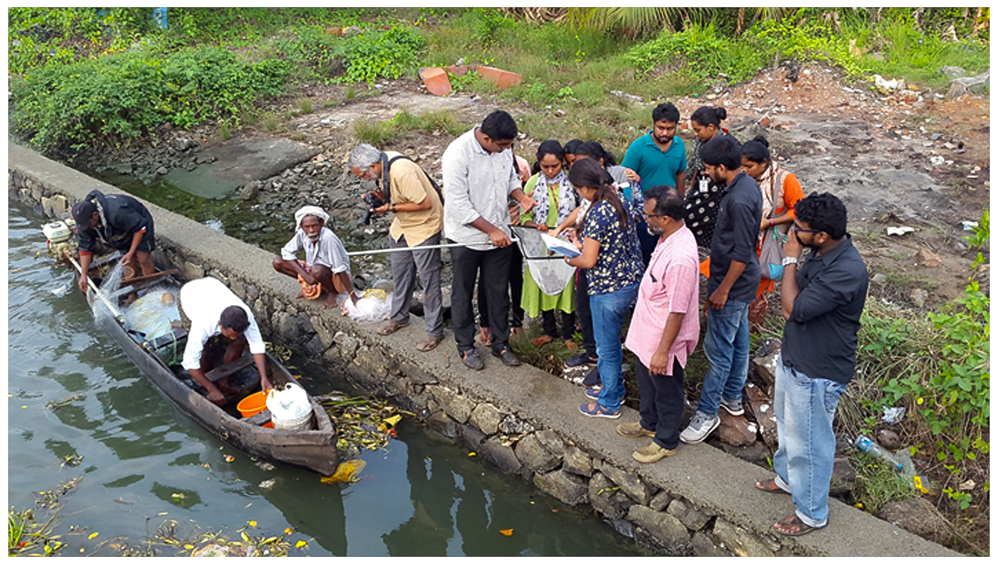Annexure – 5 (Photos)

Vembanad Post Flood Fish Count 2018

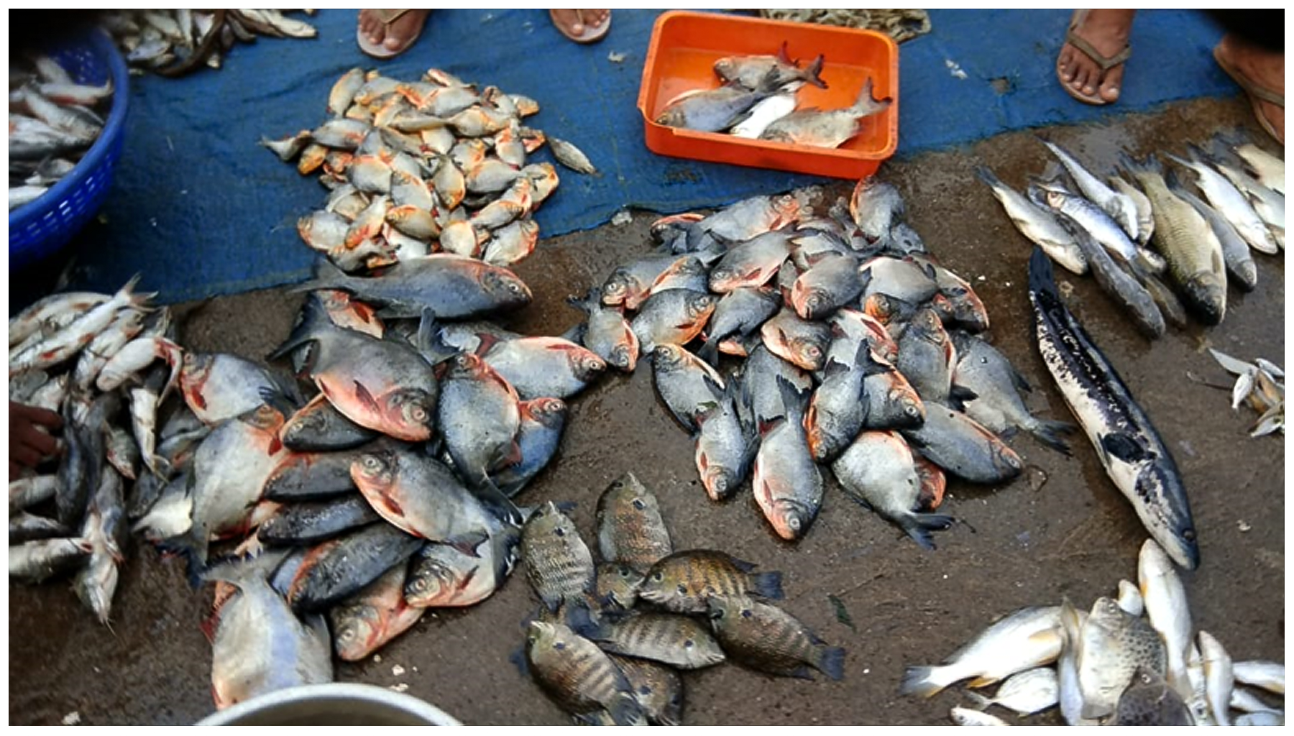
Market survey

Annexure 6. Press report
https://www.thehindu.com/news/cities/Kochi/vembanad-fish-count-records-115-species/article25894129.ece
KOCHI

Vembanad fish count records 115 species
STAFF REPORTER
KOCHI, JANUARY 03, 2019 01:42 IST

SHARE ARTICLE

- 0
- PRINT
- A A A
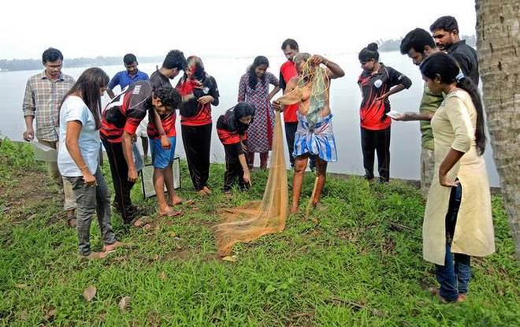
Surveyors of the post-flood Vembanad fish count inspect the fish catch of local fishermen.

Availability of fish, however, came down in the waterbody after the floods, say surveyors
The post-flood Vembanad fish count of 2018, conducted on December 21, 22, and 23 by the Ashoka Trust for Research in Ecology (ATRE) and the Community Environmental Resource Centre (CERC) to determine whether the floods had caused changes in fish diversity and resources of Vembanad Lake, has recorded the presence of 115 fish species here.

North, south surveys
Surveys began in the northern regions of the lake (the High Court, Aroorkutty, Poothotta and Manjali areas) on December 22 and concluded the next day at the Thanneermukkam bund. From these northern areas alone, the team, including those from the State Wetland Authority, ANTRIX Corporation, and the Kerala University of Fisheries and Ocean Studies (KUFOS), recorded 82 fin fishes and nine species of freshwater fish.
On December 23, the southern regions of the lake, including Thanneermukkam, Punnamada, and Kayippuram, were surveyed. The team obtained a total of 46 fin fishes and five freshwater fish from the region.
The last fish count (conducted in May 2018) had recorded a total of 110 species in the lake.
According to ATRE-CERC project coordinator Jojo T.D., the presence of marine fish and exotic fish (such as African catfish and tilapia) caused the increase in fish species. It could also be due to seasonal changes in fish species diversity as well as the heavy current that could have swept away some local fish populations.

Market survey
The survey also consisted of interviews with local fishermen who depend on the fish resources of the Vembanad Lake for livelihood as well as market surveys to determine the composition of fish catch available for sale.
The surveys and interviews showed that the availability of fish had come down post-flood.
There has also been a decrease in fish species that bring in high income for local fishermen such as pearl spot (karimeen) and shrimp. Several fishermen attributed the phenomenon to the increase in exotic species in the lake.
Other observations made during the survey included the presence of water hyacinth in the southern areas of the lake which has grown indiscriminately.
Similarly, silt deposits brought into the lake bed during the floods affected fish populations. However, detailed studies would be required to study the impact of the floods, Mr. Jojo said.

