VEMBANAD FISH COUNT REPORT- 2017

PREPARED BY
ANU RADHAKRISHNAN, MANEEJA MURALI& PRIYADARSANAN DHARMA RAJAN

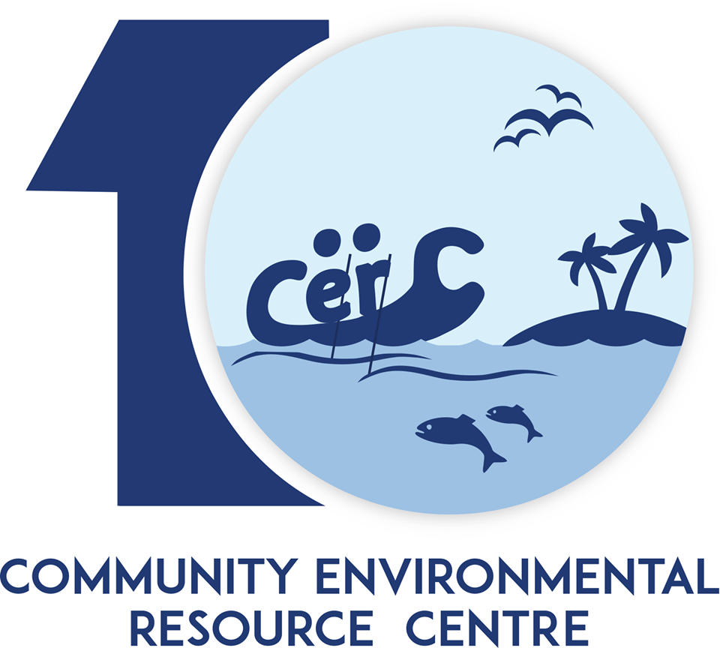

COMMUNITY ENVIRONMENTAL RESOURCE CENTRE
AMMANKOVIL STREET, MULLACKAL, ALAPPUZHA 688001
PH: 0477-2251818
www.vembanad.org
EMAIL: vembanad@atree.org

Contents
Background 3
Vembanad Fish Count 5
Objectives 6
Study Area 6
Methodology 7
Fig 1: Cruise Map (Site Wise) 8
Experimental Fishing 9
Inventory made from Fishers 10
Inventory made from Landing-centers 10
Water Quality Parameters 10
Onsite: 10
Offsite: 11
Orientation Workshop 14
Vembanad Fish Count – 2016 Report 15
Results and Discussion 16
Fig 2: Total Fin-Fish Diversity recorded south of Thannermukkom Bund of Vembanad Lake. 16
Fig 3: Total Fin-Fish Abundance recorded south of Thannermukkom Bund of Vembanad Lake. 16
Fig 3: Diversity recorded in VFC 2008-16 17
Fig 4: Feeding guild of Fin-Fishes around recorded south of Thannermukkom Bund of Vembanad Lake. 18
18
Fig 5: Habitat preference of Fin-Fishes around recorded south of Thannermukkom Bund of Vembanad Lake. 18
Suggestions 19
Reference 22
Annexure – 1 (List) 24
Fin-Fish Species List of VFC - 2016 24
Annexure – 2 (Figures) 25
Annexure – 3 (Tables) 27
Table – 1: Water Quality (Onsite) 27
Table – 2: Water Quality (Offsite) 27
Table – 3: Habitat Preference of Fin-Fishes at Southern Vembanad 28
Table 4: Vembanad Fish Count Diversity 2008-16 29

Background

Vembanad Lake (Alappuzha, Kerala) and its associated wetlands is the largest tropical wetland ecosystem on the south-west coast of India, covering an area of 1,512 km² (Ramsar, 2002) and has been designated as a Ramsar site, a wetland of global importance for its biodiversity values. Four rivers - Pampa, Meenachil, Achankovil and Manimala, originates from the Western Ghats confluence to the southern portion of Vembanad bringing the water and rich sediments and draining into the Arabian sea (Padmalal et al. 2008), thus making Vembanad the “inland fish basket” of Kerala(Padmakumar 2003; Mayaja & Srinivasa 2014). The lake is considered to be the largest fishery production unit in the south-western coast of India after the Arabian Sea. Vembanad Lake is not only home to fisheries but also to numerous migratory and resident birds (Kumar, 2006; S. P. Narayanan, Thomas, & Sreekumar, 2011).
Since the commissioning of Thannermukkom barrage there has been a drastic decline in the diversity and population of fishes( Kurup & Samuel, 1985; Kurup, et al. 1993; Padmakumar, 2003). Fishery sector is one sector that has been affected adversely due to the commissioning of Thannermukkom barrage. The annual landing of fish from the Vembanad Lake is down from about 16,000 tonnes a year in the late seventies to about 7,200 tonnes in 2000 (Unnithan, Bijoy, & Vava, 2001). Kurup et al. (1993) have reported reductions in the marine fish and prawn migration to the lake for breeding. Although the use of fishing gear leads to mass destruction and the premature catching of inland fish are legally banned, such practices continue out of livelihood needs (CERC ATREE, 2013). Even though many of the studies (Kannan 1979; Kurup & Samuel 1985; Laxmilatha & Appukuttan 2002; KrishnaKumar &Rajan 2012) have pointed out the decline in fishery resources, still the government hasn’t taken any major efforts to revive the fishery.

Vembanad Fish Count
Ashoka Trust for Research in Ecology and the Environment (ATREE) initiated the Vembanad Fish Count (VFC) asan annual participatory fish assessment in May 2008 to understand the fishery and ecological trends in Vembanad. Several institutions and agencies like the Kerala State Biodiversity Board, Department of Fisheries, Alappuzha, Government of Kerala, Department of Environment and Climate Change, Government of Kerala., Vembanad Nature Club, and Vembanad Lake Protection Forums are the co -organizers of the event. Kerala University of Fisheries and Ocean Sciences (KUFOS, erstwhile Fisheries College, Panangad), and St Albert’s College (Ernakulam) are providing the necessary technical support for the event. Vembanad Fish Count is a democratic approach in resource monitoring which is different from the conventional top-down approaches. It is a stakeholder driven program where the targeted groups participate in the entire process, learning about the situation, identifying problems, discussing alternatives, seeking solutions, designing and implementing activities, evaluating and disseminating results. In this processes, fisher folk of Vembanad share their traditional knowledge to identify problemsand solutions, ensuring that the poor and uninformed will not be excluded from decision-making and development opportunities. Such dialogue initiated during the VFC has lead the fisher community here to organize as Lake Protection Forum(LPF). 14 units of LPFs are now registered and are federated as Federation of Lake Protection Forums. LPFs are taking a leading role in organizing several conservation programs at Vembanad. One of the important activities of LPFs is the Matsyathaavalam (fish sanctuaries).Fisher folk have created 23 fishsanctuaries (no-fishing area with breedingsupports for fishes) based on their traditionalknowledge.
VFC brings together researchers, NGOs, environmentalists, students and media from Southern India. Fishers, local-self-governments, schools from around the lake are participating in this annual event and are very eager to learn about the status of fishery resources of the lake. This event has helped to consolidate views on the issues and convinced the need for immediate interventions in this sector, especially through participation of the stakeholders. The program consists of two modules; namely action &awareness.
Vembanad Fish Count – 2017, 10th edition of its kind was carried out in two major steps; viz., a participatory workshop and the fish count. In this version India Biodiversity Portal also supported us in live showcasing of the observational database.

Objectives
- To carry out an extensive survey on the fish diversity of the southern sector of Vembanad Lake.
- Capacity building to focus attention to issues on lake deterioration and biodiversity decline, into public domain.
- To understand how different types of pollution affects the Lake.

Study Area
Vembanad Lake (9° 34’ 60” N, 76° 25’ 0” E),a transitional ecotone between sea and land is the largest humid tropical wetland on the west coast of India with a length of 96 km and a surface area of 1512km². Seven rivers which originate from the Western Ghats Biodiversity Hotspot drain to the lake and eventually join the Arabian Sea. The rich biodiversity and socio economic importance, of Vembanad lake along with adjacent Kole landsled to the declaration of the lake as a Ramsar site; a wetland of international importance.The mangrove patches and islands in the lake like Pathiramanal also provide habitat for resident and seasonal migratory water fowl, otters, fish, clams, shrimps, crabs, aquatic insects and other aquatic organisms.The lake is also renowned for its live clam resources and sub-fossil shell deposits, large populations of water fowls, besides a high species diversity of finfish and shellfish (WWF 2002). (WWF, 2002). Around two hundred forty-five species of fishes were reported fromthe whole of Vembanad-Kole wetland since 1960. One hundred fifty species of fishes belonging to hundred genera and fifty-six families are known to occur in Vembanad Lake (Kurup and Samuel,1985). The list also includes vulnerable species such as Horabagrus brachysoma, Carinotetraodon travancoricus (Molur and Walker 2001). The Thannermukkom Salt Water Barragedivides the lake into two parts – the perennial brackish water part on the Northand the southern freshwater fed by the rivers draining into the lake with seasonal salt water intrusion from high tide during non-rainy seasons. These freshwater regionsof the lake are facing ecological problems due to rampant propagations of water hyacinths and eutrophication. Unmanaged and unregulated tourism and unethical fishery practicesarealso posing serious threats to theVembanad Lake. (Krishnakumar et. al., 2007).

Methodology

One hundred twenty volunteers from local stakeholders, various colleges, Universities, research institutes and Non-Governmental Agencies participated in VFC2016. The entire team was divided into three cruise groups: The KumarakomCruise (East Bank), Kuttanad (Riverine Sector) Cruise and Pathiramanal Cruise (West Bank) with 35 -40 members in each team. Each cruise team was further subdivided into four in order to assign responsibilities for
1) experimental fishing,
2) collecting data from landing centers,
3) collecting data from fishers in the lake and
4) water quality monitoring. The cruise teams conducted experiments at 15 (5X3) previously identified sampling points.
East Bank cruise | West Bank cruise | ‘Riverine cruise
Ambika Market | Kayippuram, | Punnamada
Kumarakom | Pathiramanal, | Chungam
Nazreth | Muhamma, | Kainakary,
Chithira Kayal | Mannancheri | Aarayiram Kayal
R Block. | Aryad | Sai

The program commenced from 6 am and extended till 3 pm on 27th of May 2017.
A week before the survey, an expert team of fish taxonomists explored around the lake for fish landing centre inventory and collected thedata from Vaikom and Pallom landing centres during the early morning hours. In addition to this on the day of fish count Ambika Market located near Thannermukkom bund and Punnamada landing centre respectively was also surveyed in the morning by students and experts.
As part of capacity building an orientation workshop (participatory workshop) was arranged on the day before fish count in order to capacitate the participants on their duties and responsibilities and etiquettes to be followed during fish count. A fish identification guide, water quality analysis and collection kit along with GPS were provided to carry out the exercise.

Fig 1: Cruise Map (Site Wise)
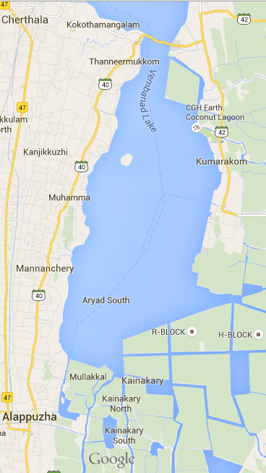



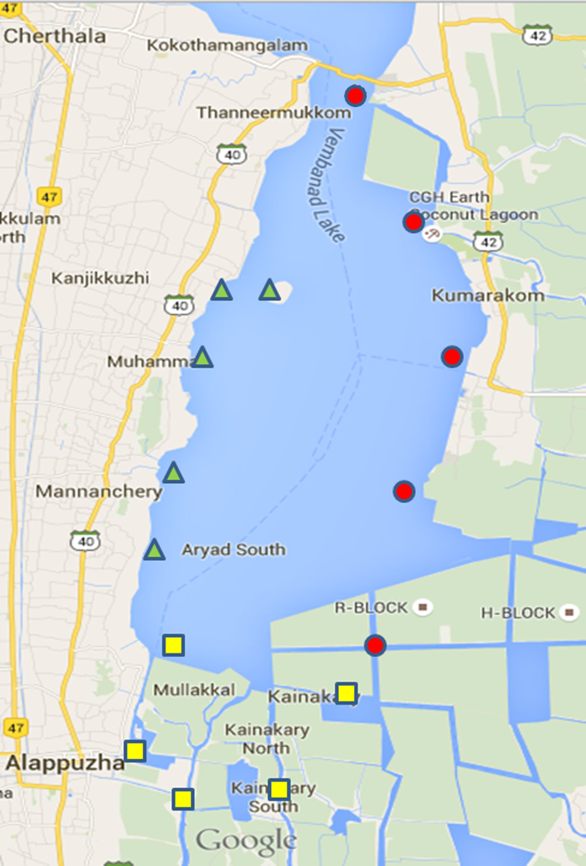

N

East Cruise
West Cruise
Riverine Cruise

Experimental Fishing
This was facilitated with the help of local fishers who accompanied the cruise at all different stations using three major fishing gears, namely;
- Gill Net: One gill net each was laid at six locations; i.e., at two sites for each cruise. The nets were laid by around 2am and was retrieved by 6am. The collection was ice preserved till each team arrived for inspection. All entries were made on to the survey forms distributed to the participants
- Cast Net: Cast net was thrown at five points each at all five sites of each cruise (total = 5X5X3). Entries were made as mentioned above. The specimens obtained were either left back after successful identification and counting or collected in alcohol/formalin depending upon the use to be carried out later on. Alcohol preservation was preferred in case of DNA analysis and formalin in case of further morphological lab examination.
- Scoop Net: Scoop net was also carried out five times at each at all five sites of each cruise and the following activities were done as the same as above.
The abundance (number of individuals at each sampling point) and diversity (type of each species) data had been recorded on the respective survey forms provided to the participants. An additional replicate data was also collected this year in order to maintain track of the number of individuals obtained per each netting.

Inventory made from Fishers
This was carried out with the due participation of local fishers who allowed us to check the species, which contributed to their catch on the count day. Enquiries were also made on the fishing methods and socio-economic information of the fishers. The obtained informationwasrecorded to the respective survey forms.

Inventory made from Landing-centers
The major landing centers around the sampling sites viz. Punnamada, Pallom and Vaikom were visited on the two consecutive days prior to fish count and the species diversity were recorded. The type of gear used and the percentage of commercially important fishes to the catches were recorded in consultation with the fishers.

Water Quality Parameters
Water quality parameters were tested onsite as well as offsite.

Onsite:
- pH: pH is a numeric scale used to specify the acidity or basicity of an aqueous solution. pH was measured using standard pH solution marketedbyC.P.R. Environmental Education Centre, Chennai (CPREC). Water samples were collected and analyzed 3 times each to arrive at concordant values. In addition, samples were also taken aboard for confirmatory lab analysis.
- Transparency: Transparency of water relates to the depth that light penetrates water. As light penetrates water, it becomes attenuated and altered in its spectral composition. The change that occurs is from predominantly yellow light at the surface to blue-green at depth in clear water or yellow-green in waters having a high concentration of dissolved organic material. Secchi disk is a simple device used to measure the transparency of water bodies. Water clarity is related to amounts of suspended particles (turbidity) as well as amounts of phytoplankton and zooplankton. Seechi readings were carried out at all sites and valued were recorded on to survey forms.
- Temperature (atmospheric/water): Temperature exerts a major influence on the biological activity and growth of aquatic organisms. Both water and atmospheric temperatures were measured at all sites using alcohol based laboratory thermometers. Results were recorded on to survey forms.
- Salinity: Salinity is the amount of dissolved salt substance of the water. Salts are compounds like sodium chloride, magnesium sulfate, potassium nitrate, and sodium bicarbonate which dissolve into ions. Salinity was measured at all sites using a salinometer and the readings were recorded on to survey forms.
Offsite: Water samples were collected in 500ml water bottles to be analyzed at Kerala State Pollution Control Board (KSPCB) affiliated labs. Water samples forestimation of dissolved oxygen was fixed in field using Winkler A and B respectively after which all samples where preserved in ice boxes.
- Total Hardness: Total hardness is defined as the sum of calcium and magnesium hardness (Even though Fe²⁺, Fe³⁺, Sr²⁺, Zn²⁺, and Mn²⁺ may contribute to water hardness, their levels are typically much less than Ca²⁺ and Mg²⁺. Their levels are not usually included in total hardness measurements) in mg/L as CaCO₃. Ideal quality water should not contain more than 80 mg/L of total hardness as CaCO3. (Vernier).
- Dissolved Oxygen (DO): Dissolved oxygen (DO) is the amount of oxygen that is present in the water. It is measured in milligrams per liter (mg/L), or the number of milligrams of oxygen dissolved in a liter of water. Samples to be analyzed was collected using Winkler method.
- Nitrate: Presence of nitrate in lakes could be from agriculture run-off waters as fertilizers are considerably made of nitrate owing to its high solubility and biodegradability. (Laue et al., 2006). Presence of normal levels of nitrates usually does not have a direct effect on aquatic organisms. Algae and other plants use nitrates as a source of food. If algae have an unlimited source of nitrates, their growth is unchecked. This could lead to “Eutrophication”, anoxia to lake conditions etc. Levels exceeding 50 mg/L (ppm) nitrate-nitrogen are considered unhealthy for lakes.
- Nitrite:Nitrites occur in water as an intermediate product in the biological breakdown of organic nitrogen, being produced either through the oxidation of ammonia or the reduction of nitrate. The presence of large quantities of nitrites is indicative of waste water pollution. Levels exceeding 0.55 mg/L (ppm) nitrite-nitrogen can cause 'brown-blood' disease in finfish.
- Iron: Concentrations above 1 mg/L will impart a foul taste to the water. High concentrations can indicate runoff from mining operations or industrial effluent and indicate the need for further investigation before prescribing a treatment regimen. Proper lake water limit levels are unavailable.
- Phosphate: High phosphate concentrations in surface waters may indicate fertilizer runoff, domestic waste discharge, or the presence of industrial effluents or detergents. If high phosphate levels persist, algae and other aquatic life will flourish, eventually decreasing the level of dissolved oxygen due to the accelerated decay of organic matter. Algae blooms are encouraged by levels of phosphate greater than 25 micrograms/L.
- Others: Magnesium, Calcium and Sulphate were the other measured parameters.

OrientationWorkshop
Orientationworkshop for the participants was conducted on 26th May 2017 at Karmasadan, Alappuzha Convent Square at 6 pm. Shri. Jojo T. D (Project Coordinator, ATREE-CERC) delivered the welcome address. Dr. Priyadarsanan Dharma Rajan (Senior Fellow, ATREE-Bangalore) chaired the inaugural session. Prof. K.V. Jayachandran (Retd. Director of Research, KUFOS), inaugurated the function. The orientation for 120 volunteers of Vembanad fish count was given by Mr. Anu Radhakrishnan (Research Associate, ATREE-Bangalore) where he discussed a brief history of Vembanad and CERC’s activities,and the objectives ofVembanad Fish Count. Methodology used for data collection and the basic etiquettes and discipline/safety measures to be followed during the cruise. Participants for the program were divided into three teams. For each team,a cruise leader was selected, who were assigned the task of making the organizational groups and functional groups for effective conduct of the survey. Fishing gears, resource materials and survey forms were distributed to each team before dispersing for dinner. The three designated teams were East bank (Starting from Kumarakom), West Bank (Kayippuram) and Riverine (Starting from Alappuzha).Dr. Rajeev Raghavan (Assistant Professor, KUFOS), Ms. Maneeja Murali (Program Officer, ATREE-CERC) and Ms. Shoba Marina George (Program Officer, ATREE-CERC) were the resource persons for Riverine, East and West cruises respectively.

Vembanad Fish Count – 2017 Report
On 27th May Fish Count was flagged off by Mr. K. V. Dayal, a noted environmentalist at Kayippuram Jetty, Muhamma; the West bank and East bank cruise started from this point. The other starting point was Punnamada – Alappuzha.
The cruise boats moved towards each sites where the team halted for approximately 35-45mins and conducted experimental fishing with the help of different gears; viz. gill net, cast net and scoop net. Onsite water quality data and water for offsite analysis were also collected along with data pertaining to fish habitats including primary visual data. The team members of each cruise also discussed and compiled the data collected, to make a rough presentation in the concluding session.
All teams returned to the finishing point; boat jetty Alappuzha by 3:00 pm. The concluding session was held at Pulimoottil Trade Centre, Mullackkal, Alappuzha. The returning cruise teams were received and valedictory session was inaugurated by Shri. G. Venugopal (Hon’ President, Alappuzha District Panchayat) The meeting was presided over by Dr. Priyadarsanan Dharma Rajan (Senior Fellow, ATREE). Shri. Jojo T.D (Coordinator, ATREE-CERC) delivered the welcome address. The program was inaugurated by Dr. A. Ramachandran (Vice Chancelor, KUFOS). Shri. Rakesh Sasibushan (Chairman & Managing Director, Antrix Corporation Ltd.) was the special guest of honour. Dr. M. K. Sajeevan (Assistant Professor, KUFOS) summed up the report during the function, he said this year 49fin-fish species, 4 crustaceans, and 1 molluscs were found from the fish count. It was relatively more than the last year’s fish count. The presence of Nematlosa nasus locally known as ‘Thodi’ was the major highlight. The species is mainly marine and occasionally migrate towards the estuarine areas mainly in search of breeding grounds and also better food sources. It was also noted that there was an increase in the number of the Pearl Spot and Prawns. The participants also recorded21species of water birds during this Fish Count. The salinity marked around 2-4 ppt last year has increased to 2-7 ppt this year. Shri. K. M. Poovu (Secretary, Lake Protection Forum) delivered the vote of thanks.

Results and Discussion
A total of 46 fin-fish species from 23 families, 8 species of Crustaceans from 6 families and 1 species of Molluscs were recorded during Vembanad Fish Count – 2017with a total abundance of 2253 individuals. (Annexure-1).

Fig 2: Total Fin-Fish Diversity recorded south of Thannermukkom Bund of Vembanad Lake.
Vembanad Fish count (VFC 2008-2017) has recorded 71 species of fin fishes and 14 species of shell fishes so far (2008-17) from Vembanad Lake.

Fig 3: Total Fin-Fish Abundance recorded south of Thannermukkom Bund of Vembanad Lake.

Fig 2: Diversity recorded in VFC 2008-17

Fig 4; Fin Fishes recorded with more than 100 individuals from three cruises.
Water chemistry of VFC 2017 portrayed an average pH, water temp. and DO (% sat.) of 6.5, 32°C and 82% respectively. A healthy estuarine ecosystem ideally should show a pH b/w 7-9 and DO b/w 80-110% (Water watch Estuary Guide, 2010). 2017 result shows that the health of the ecosystem is at satisfactory; aquatic plants and animals may be at reviving compared to the stress that had been portrayed year. Optimum DO levels can be attributed towards strict fishing policies implemented by the LPF’s as people using lake are involved in LPF’s and are better aware about the deterioration conditions happening within the lake. Lake water pollution at Vembanad includes; sewage from municipal areas, sewage and other organic waste discharge from house boats, agricultural run offs, plastic items etc.
The fin fish diversity recorded was 12% more than the previous year when only 38 fin-fish species had been reported. Highest abundance and Diversity was reported at Eastern Cruise (Abundance;954. Diversity;29 species) Meanwhile, lowest abundance was reported at Riverine Criuse with 543 individuals and lowest diversity at Western Cruise with 24 species only. pH ranged between 6.09-6.92; High pH and low salinity (2.60ppt) was recorded at Riverine Cruise with decreased abundance. Low pH and high salinity (5.23 ppt) was recorded at Eastern Cruise with increased abundance and Species Diversity. Water temperature showed a range of 30-32⁰C.Total Hardness as CaCO₃ ranged 302-4200 ppm. Dissolved oxygen ranged between 2.8 -9.2 mg/L.
Feeding guild: All fin-fishes recorded had been classified into seven categories; namely – Herbivorous, Carnivorous, Omnivorous, Insectivorous,Carnivore & Insectivore, Detritivore, and Carnivore & Detritivore. Dominance of carnivores and certain omnivores over herbivores is certainly not a good sign of sustainable existence of the ecosystem in the long run.
Based on their habitat preference, fishes were classified into Freshwater only (F), Fresh-Brackish (FB), Brackish-Marine (BM) Fresh-Brackish-Marine (FBM) and Marine only (M). FB dominated the count which was followed by F, FBM, BM &M. In summer season the lake remains brackish due less freshwater influx from the rivers and higher in surge of salt water into the system from the sea, resulting in higher FB availability. Abundance of FBM was higher in freshwater zone compared to that of the other two, this trend indicates that the fishes might be migrating to the freshwater zones for its breeding.

Suggestions

● The state and central Governments should put efforts to sustain the fisheries sector through a holistic approach which includes habitat protection, enforcement of regulations and adoption of co-management strategies. This will lead to improving the livelihoods of fishers and avoiding further degradation and deterioration of habitat quality of the ecosystem.
● Regular Fish survey and water quality analysis should be conducted during all three seasons viz. Monsoon (June-August), Post-Monsoon (October-November) and Pre-Monsoon (March-April) maybe carried out for at least 3 years to make better estimation on fish diversity and ecosystem health of the lake. Long term monitoring mechanism on population dynamics of various fish species which are thought to be declining and study the effect of Thannermukkom Bund on migratory fishes Vembanad should be taken up through collaborative projects involving various research organizations.
● Develop an Index for lake conservation like Index of Biotic Integrity (IBI) forVembanad Lake ecosystem (standards for water quality and the organisms inhabiting the lake indicating ecosystem health) and regular monitoring to ensure its sustainable health.
● Awareness programs should be conducted within the community inhabiting around the lake and tourists visiting the ecosystem regarding its global importance in sustainable living and existence of all living organisms and the bigger role it could play in mitigating global climate change and ecological vulnerability if developed as a conservation model.
● Whenever wherever possible undisturbed areas of Vembanad Lake/Kole should be maintained as such to retain its pristine nature to set itself as control and scale up the health levels of the rest of the areas to a standard point possible.
● Strict pollution control policies should be developed and implemented in compliance with Wetland and Paddy Conservation Act 2008.
● A strict fishing policy should be formulated by analyzing various methods currently used in the ecosystem so that only the most sustainable ones are selected for practice in lake.
● Existing natural habitats and native vegetation like those surrounding Pathiramanal islands, the reclaimed portions of lake at Chithira and Rani Block of kayals should be declared as No Take Zones.
● Develop breeding and hatchery protocols for fishes that are used in ranching and stock enhancements.
● Measures should be taken to protect riparian and indigenous macrophytes inhabiting the lake.
● Ban monsoon flood plain fishery (Ootha piditham) when spawning individuals are largely targeted.
● stablishing a democratic-management system should be a top priority for fisheries planners in the Vembanad. This should be based on a bottom-up strategy rather than the conventional top-down schemes which have been a failure.
● Collaborations between various central and state government organizations, research institutes, universities, colleges, non-governmental organizations and cooperatives with due participation of local stake holders should be made and efficient programs for protecting the lake, its resources and the livelihoods of the fishers depending on the ecosystem should be adapted.
● Municipal drains should empty to the lake only after proper treatments and the water disposed henceforth should meet the ideal standards of estuarine lake water or freshwater system.

Reference
● Asha, C. V, Cleetus, R. I., Suson, P. S., & Nandan, S. B. (2015). Environmental factors structuring the Fish assemblage distribution and Production potential in Vembanad estuarine system, India. International Journal of Marine Science, 5.
●Bates, Roger G. Determination of pH: theory and practice. Wiley, 1973.
●CERC ATREE. (2013). Participatory Mapping of Natural Resources in Vembanad Lake. Retrieved from www.vembanad.org
●Commission, P. (2008). Report on Visit to Vembanad Kol, Kerala, a Wetland Included Under the National Wetland Conservation and Management Programme of the Ministry of Environment and Forests. Retrieved from http://203.200.22.249:8080/jspui/handle/123456789/4074.
●Dunbar, Jeffery A (2001) Casting net NC Coastal fishing. Retrieved 25 August 2008.
●Florence, M. A. (2012). Sustainability and livelihood issues of Vembanad Ecosystem fisherfolk communities with special reference to Muhamma and Thanneermukkom villages.
●Fondriest Environmental, Inc. “Dissolved Oxygen.” Fundamentals of Environmental Measurements. 19 Nov. 2013. Web. <http://www.fondriest.com/environmental-measurements/parameters/water-quality/dissolved-oxygen/>
●Geetha, R., Chandramohankumar, N., & Mathews, L. (2007). Distribution of total reactive fluoride in sediments of Kuttanad waters. INDIAN JOURNAL OF ENVIRONMENTAL PROTECTION, 27(11), 1001.
●Hedley, M. J., Stewart, J. W. B., & Chauhan, B. (1982). Changes in inorganic and organic soil phosphorus fractions induced by cultivation practices and by laboratory incubations. Soil Science Society of America Journal, 46(5), 970-976.
●Kannan, K. (1979). Ecological and socio-economic consequences of water-control projects in the Kuttanad region of Kerala. Proceedings of the Indian Academy of Sciences Section C: Engineering Sciences, 2(4), 417–433.
●Kannan, K. P. (1979). Ecological and socio-economic consequences of water-control projects in the Kuttanad region of Kerala. Proceedings of the Indian Academy of Sciences Section C: Engineering Sciences, 2(4), 417–433.
●KrishnaKumar, K., & Dharmarajan, P. (2012). Fish and Fisheries in Vembanad Lake Consolidated Report of Vemband Fish Count 2008-2011.
●Kumar, A. B. (2006). A checklist of avifauna of the Bharathapuzha river basin, Kerala. Zoo Print, 21(8), 2350–2355.
●Kurup, B., & Harikrishnan, M. (2000). Reviving the Macrobrachium rosenbergii (de Man) fishery in Vembanad lake, India. Naga, The ICLARM Quarterly, 23(2), 4–9.
●Kurup, B. M., & Samuel, C. T. (1985). Fish and fishery resources of Vembanad Lake. Harvest and Post-Harvest Technology of Fishes. Central Institute of Fisheries Technology (CIFT) &Society of Fisheries Technologists (SOFTI), Kochi, India, 77–82.
●Kurup, B. M., Sebastian, M. J., Sankaran, T. M., & Rabindranath, P. (1993). Exploited fishery resources of the Vembanad Lake. Indian Journal of Fisheries, 40(4), 199–206.
●Laxmilatha, P., & Appukuttan, K. K. (2002). A review of the black clam (Villorita cyprinoides) fishery of the Vembanad Lake. Indian Journal of Fisheries, 49(1), 85–92.
●M.S. Swaminathan Research, F. (2007). Measures to Mitigate Agrarian Distress in Alappuzha and Kuttanad Wetland Ecosystem.
●Manorama, K. C., & Agricultural, K. (n.d.). Nature Watch.
●Mayaja, N. A., & Srinivasa, C. V. (2014). Rainfall characteristics of Pampa river basin, Kerala: A time series analysis.
●Michaud, J.P. 1991. A citizen's guide to understanding and monitoring lakes and streams. Publ. #94-149. Washington State Dept. of Ecology, Publications Office, Olympia, WA, USA (360) 407-7472. Moore, M.L. 1989.
●Murphy, B. R., & Willis, D. W. (Eds.). (1996). Fisheries techniques (2nd ed., p. 732). Bethesda, Maryland: American fisheries society.
●Narayanan, N. C. (2003). Against the grain: the political ecology of land use in a Kerala region, India.
●Narayanan, S. P., Thomas, A. P., & Sreekumar, B. (2011). Ornithofauna and its conservation in the Kuttanad wetlands, southern portion of Vembanad-Kole Ramsar site, India. Journal of Threatened Taxa, 3(4), 1663–1676.
●Padmakumar, K. G. (2003). Open water fish sanctuaries. Kerala Calling, 23(6), 34–36.
●Padmalal, D., Maya, K., Sreebha, S., & Sreeja, R. (2008). Environmental effects of river sand mining: a case from the river catchments of Vembanad lake, Southwest coast of India. Environmental Geology, 54(4), 879–889.
●Ramsar. (2002). VEMBANAD-KOL WETLAND. Retrieved from https://rsis.ramsar.org/ris/1214
●Samuel, C. T. (2014). Studies on systematic and biology of the fishes of Vemabanad lake.
●Sathyanathan, N. (2010). Overview of farming practices in the water-logged areas of Kerala, India. International Journal of Agricultural and Biological Engineering, 3(4), 28–43.
●Suseelan, C. (1987). Impact of environmental changes and human interference on the prawn fishery resources. Marine Fisheries Information Service, Technical and Extension Series, 73, 1–5.
●Unnithan, V. K., Bijoy, N. S., & Vava, C. K. (2001). Ecology and fisheries investigations in Vembanad Lake. CICFRI Bull, (107).
●Wolfgang Laue, Michael Thiemann, Erich Scheibler, Karl Wilhelm Wiegand "Nitrates and Nitrites" in Ullmann's Encyclopedia of Industrial Chemistry, 2006, Wiley-VCH, Weinheim.
http://www.alken-murray.com/

Annexure – 1 (List)

Fin-Fish Species List of VFC – 2017
Sl No; | SPECIES
3 | Ambassis ambassis
5 | Carinotetraodon travancoricus
6 | Etroplus suratensis
7 | Dawkinsia filamentosa
8 | Horadandia brittani
9 | Amblypharyngodon melettinus
10 | Gerres setifer
12 | Glossogobius giuris
15 | Brachirus orientalis
16 | Aplocheilus lineatus
18 | Hyporhamphus xanthopterus
23 | Chelon planiceps
25 | Alepes djedaba
26 | Heteropneustes fossilis
30 | Aplocheilus panchax
31 | Channa striata
32 | Eleotris fusca
33 | Eubleekeria splendens
37 | Dayella malabarica
38 | Johnius dussumieri
45 | Johnius dussumieri
39 | Labeo dussumieri
46 | Labeo dussumieri
34 | Macrognathus guentheri
35 | Megalops cyprinoides
40 | Mugil cephalus
27 | Mystus armatus
19 | Mystus gulio
36 | Mystus oculatus
41 | Nandus nandus
20 | Nematalosa nasus
11 | Parambassis dayi
4 | Parambassis ranga
1 | Parambassis thomassi
21 | Photopectoralis bindus
2 | Pseudetroplus maculatus
17 | Pseudophromenus capanus
28 | Pseudosphromenus dayi
14 | Puntius amphibius
24 | Puntius mahecola
13 | Puntius vittatus
42 | Scatophagus argus
43 | Siganus javus
22 | Stenogobius
44 | Stolephorus indicus
29 | Systomus sarana

Annexure – 2 (List)
Species recorded from the Landing Centre Pallom
PALLOM
Sl No | FIN FISHES
1 | Mystus gulio (Hamilton 1822)
2 | Channa marulius (Hamilton 1822)
3 | Pseudetroplus maculatus(Bloch 1795)
4 | Channa striata (Bloch 1793)
5 | Channa diplogramma (Day, 1865)
6 | Heteropneustes fossilis (Bloch 1794)
7 | Labeo dussumieri (Valenciennes 1842)
8 | Macrognathus guentheri (Day 1865)
9 | Systomus sarana (Hamilton 1822)
10 | Megalops cyprinoides (Broussonet 1782)
11 | Horabagrus brachysoma (Günther 1864)
12 | Mystus armatus (Day 1865)
13 | Hyporhamphus xanthopterus (Valenciennes 1847)
14 | Etroplus suratensis (Bloch 1790)
15 | Puntius filamentosus (Valenciennes 1844)

Annexure- 3( List)
Species recorded from Thanneermukkom Market.
Thanneermukkom Market Survey
SL No; | Species
1 | Mystus gulio (Hamilton 1822)
2 | Leiognathus equula (Forsskål 1775)
3 | Channa marulius (Hamilton 1822)
4 | Anabas testudineus (Bloch 1792)
5 | Pseudetroplus maculatus(Bloch 1795)
6 | Thryssa dussumieri (Valenciennes 1848)
7 | Gerres filamentosus Cuvier 1829
8 | Brachirus orientalis (Bloch & Schneider 1801)
9 | Terapon jarbua (Forsskål 1775)
10 | Channa striata (Bloch 1793)
11 | Heteropneustes fossilis (Bloch 1794)
12 | Saurida tumbil (Bloch 1795)
13 | Systomus sarana (Hamilton 1822)
14 | Clarias dussumieri Valenciennes 1840
15 | Puntius filamentosus (Valenciennes 1844)
16 | Macrognathus guentheri (Day 1865)
17 | Horabagrus brachysoma (Günther 1864)
18 | Mystus armatus (Day 1865)
19 | Sillago sihama (Forsskål 1775)
20 | Arius subrostratus Valenciennes 1840
21 | Nematalosa nasus (Bloch 1795)
22 | Siganus javus (Linnaeus 1766)
23 | Anodontostoma chacunda (Hamilton 1822)
24 | Megalops cyprinoides (Broussonet 1782)
25 | Labeo dussumieri (Valenciennes 1842)
26 | Elops machnata (Forsskål 1775)

Annexure – 3 (Figures)
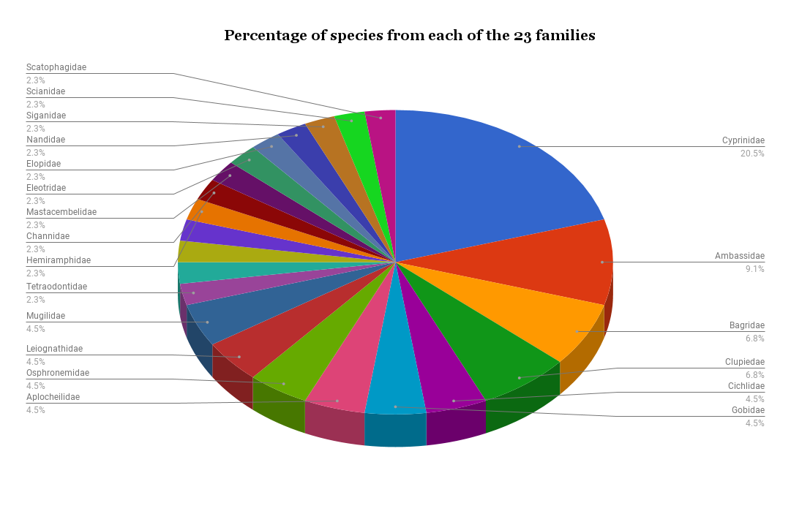
Fig. 6. Percentage of species from each family reported

Annexure – 3 (Tables)

Table – 1

WATER QUALITY PARAMETERS
 | Sample | pH | Conductivity (mS/m) | Chloride (mgCl/L) | Salinity (ppt) | Hardness (mgCaCO3/L) | DO (mg/L) | Iron | Sulphate | Nitrate | Phosphate

EASTERN CRUISE
EASTERN CRUISE | S1 | 6.05 | 10.72 | 3930.29 | 7.33 | 4200 | 6 | 10.489 | 206.217 | 0.648 | 0.216
EASTERN CRUISE | S2 | 6.01 | 8.37 | 3008.04 | 5.61 | 3200 | 6.4 | 9.706 | 147.241 | 0.316 | 0.757
EASTERN CRUISE | S3 | 6.18 | 7.82 | 2777.48 | 5.18 | 3200 | 6 | 13.15 | 163.579 | 0.207 | 0.937
EASTERN CRUISE | S4 | 6.04 | 6.03 | 2123.32 | 3.96 | 2000 | 5.2 | 14.09 | 178.921 | 0.39 | 0.239
EASTERN CRUISE | S5 | 6.17 | 6.28 | 2203.75 | 4.11 | 2200 | 5.6 | 10.176 | 157.502 | 0.232 | 0.37
WESTERN CRUISE | S1 | 6.05 | 10.46 | 3833.78 | 7.15 | 3600 | 5.2 | 17.69 | 194.86 | 0.706 | 1.334
WESTERN CRUISE | S2 | 6.08 | 8.78 | 3147.45 | 5.87 | 2800 | 5.6 | 25.205 | 207.711 | 0.681 | 0.761
WESTERN CRUISE | S3 | 6.56 | 7.91 | 2857.9 | 5.33 | 2600 | 8 | 22.387 | 156.605 | 0.24 | 0.317
WESTERN CRUISE | S4 | 6.89 | 6.36 | 2230.56 | 4.16 | 2600 | 9.2 | 15.342 | 121.837 | 0.232 | 0.21
WESTERN CRUISE | S5 | 7.06 | 5.42 | 1882.03 | 3.51 | 1800 | 8 | 17.69 | 123.929 | 0.681 | 0.006
RIVERINE CRUISE | S1 | 7.07 | 3.4 | 1147.45 | 2.14 | 474 | 4 | 23.17 | 99.92 | 0.066 | 0.208
RIVERINE CRUISE | S2 | 6.85 | 2.29 | 756.03 | 1.41 | 302 | 2.8 | 17.534 | 79.299 | 0.191 | 1.762
RIVERINE CRUISE | S3 | 6.92 | 4.01 | 1361.93 | 2.54 | 520 | 6 | 10.019 | 98.028 | 0.166 | 0.381
RIVERINE CRUISE | S4 | 6.84 | 5.82 | 2048.25 | 3.82 | 648 | 4.4 | 14.246 | 138.673 | 0.033 | 0.514
RIVERINE CRUISE | S5 | 6.92 | 4.88 | 1678.28 | 3.13 | 380 | 8 | 26.927 | 104.603 | 0 | 0.145

Table 4: Vembanad Fish Count Diversity 2008-17

Vembanad fish Count | Fin fish | Shell fish
1985 & 1989 (Kurup et.al.) | 60 | -
2008 | 50 | 11
2009 | 62 | 14
2010 | 52 | 14
2011 | 45 | 9
2012 | 57 | 05
2013* | 31 | 10
2014 | 45 | 10
2015 | 45 | 05
2016 | 39 | 05
2017 | 46 | 8
Table 1: No of fishes recorded in each fish count

Orientation Workshop

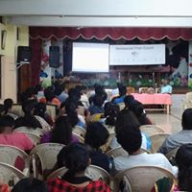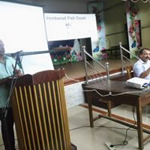

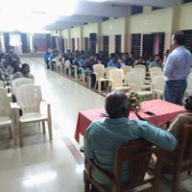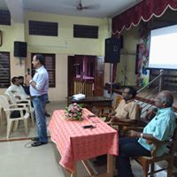

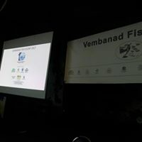
Vembanad Fish Count- 2017

