VEMBANAD POST FLOOD FISH COUNT
REPORT- 2019

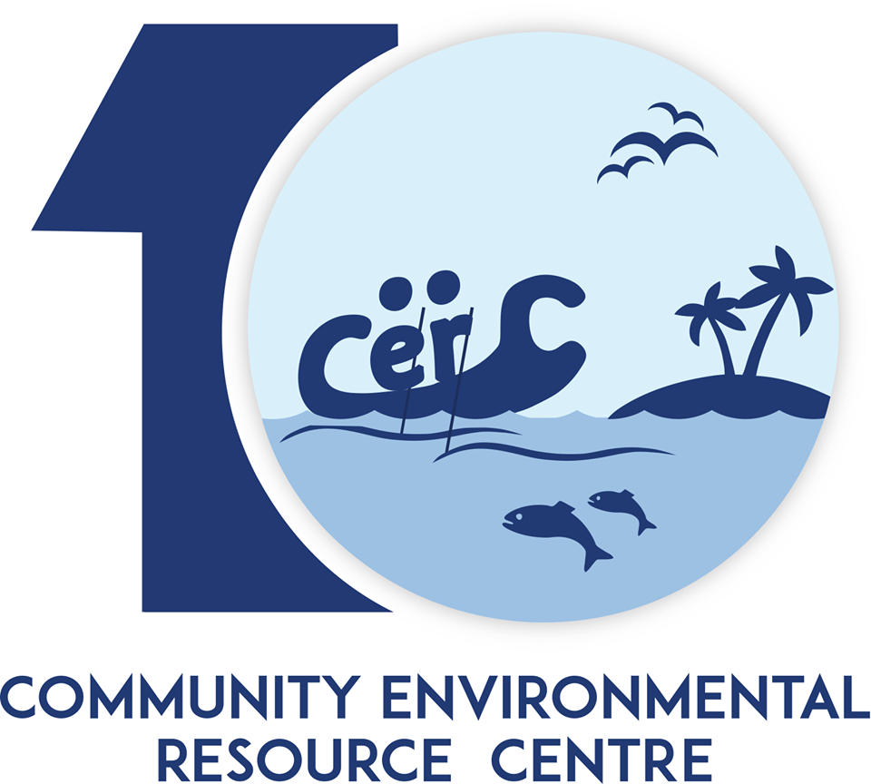

COMMUNITY ENVIRONMENTAL RESOURCE CENTRE
AMMANKOVIL STREET, MULLACKAL, ALAPPUZHA 688001
PH: 0477-2251818
www.vembanad.org
EMAIL: vembanad@atree.org

Contents
Vembanad Fish Count 5
Objectives 6
Study Area 6
Methodology 7
Fig 1: Cruise Map (South) 10
Fig 1: Cruise Map (North) 11
Experimental Fishing 12
Inventory made from Fishers 12
Inventory made from Landing-centers 13
Water Quality Parameters 13
Onsite: 13
Offsite: 14
Vembanad Fish Count – 2019 Report 17
Results and Discussion 17
Suggestions 18
Reference 20
Annexure – 1 (List) 24
Fin-Fish Species List of VFC – 2018 24
Annexure – 2 (Water quality) 30
Annexure – 3 (Photos) 32

Background

Vembanad Lake (Alappuzha, Kerala) and its associated wetlands is the largest tropical wetland ecosystem on the south-west coast of India, covering an area of 1,512 km² (Ramsar, 2002) and has been designated as a Ramsar site, a wetland of global importance for its biodiversity values. Four rivers - Pampa, Meenachil, Achankovil and Manimala, originates from the Western Ghats confluence to the southern portion of Vembanad bringing the water and rich sediments and draining into the Arabian sea (Padmalal et al. 2008), thus making Vembanad the “inland fish basket” of Kerala(Padmakumar 2003; Mayaja & Srinivasa 2014). The lake is considered to be the largest fishery production unit in the south-western coast of India after the Arabian Sea. Vembanad Lake is not only home to fisheries but also to numerous migratory and resident birds (Kumar, 2006; S. P. Narayanan, Thomas, & Sreekumar, 2011).
Since the commissioning of Thannermukkom barrage there has been a drastic decline in the diversity and population of fishes( Kurup & Samuel, 1985; Kurup, et al. 1993; Padmakumar, 2003). Fishery sector is one sector that has been affected adversely due to the commissioning of Thannermukkom barrage. The annual landing of fish from the Vembanad Lake is down from about 16,000 tonnes a year in the late seventies to about 7,200 tonnes in 2000 (Unnithan, Bijoy, & Vava, 2001). Kurup et al. (1993) have reported reductions in the marine fish and prawn migration to the lake for breeding. Although the use of fishing gear leads to mass destruction and the premature catching of inland fish are legally banned, such practices continue out of livelihood needs (CERC ATREE, 2013). Even though many of the studies (Kannan 1979; Kurup & Samuel 1985; Laxmilatha & Appukuttan 2002; Krishna Kumar &Rajan 2012) have pointed out the decline in fishery resources, still the government hasn’t taken any major efforts to revive the fishery.
In this existing scenario, Kerala has faced its worst floods in 94 years on August 2018 and is still crawling to normality from its aftermath. Land-slides, land-slips, course change in river flow, etc. severely affected almost all topographic levels of land area which included highland, midland, and lowland. Several organisms in the higher altitudes and from the aquaculture farms got displaced in this course, and many had to face sad demise due to anthropogenic as well as miscellaneous reasons, especially reptiles and fishes. Displacement of fishes during floods from a higher altitude to a lower level is a global reality, and in the case of Vembanad as well, it was no different. The need for this study had been set as fisher folks in the area started coming across foreigner fishes in the estuary which was then not common in the open and too in very huge amounts. As the discovered ones were freshwater species and also as Vembanad did possess certain areas with freshwater logging at least in some part of every year, the existence of the former posed the question of the species’ chance of acclimatisation and procreation in the system, which might prove fatal for the native species if invaded. In this background ATREE CERC proposed a post flood fish count to assess the fish stock diversity in Vembanad wetlands. The project was supported by the State Wetland Authority, Kerala (SWAK).

Vembanad Fish Count
Ashoka Trust for Research in Ecology and the Environment (ATREE) initiated the Vembanad Fish Count (VFC) is an annual participatory fish assessment in May 2008 to understand the fishery and ecological trends in Vembanad. Several institutions and agencies like the Kerala State Biodiversity Board, Department of Fisheries, Alappuzha, Government of Kerala, Department of Environment and Climate Change, Government of Kerala., Vembanad Nature Club, and Vembanad Lake Protection Forums are the co -organizers of the event. Kerala University of Fisheries and Ocean Sciences (KUFOS, erstwhile Fisheries College, Panangad), and St Albert’s College (Ernakulam) are providing the necessary technical support for the event. Vembanad Fish Count is a democratic approach in resource monitoring which is different from the conventional top-down approaches. It is a stakeholder driven program where the targeted groups participate in the entire process, learning about the situation, identifying problems, discussing alternatives, seeking solutions, designing and implementing activities, evaluating and disseminating results. In this processes, fisher folk of Vembanad share their traditional knowledge to identify problemsand solutions, ensuring that the poor and uninformed will not be excluded from decision-making and development opportunities. Such dialogue initiated during the VFC has lead the fisher community here to organize as Lake Protection Forum(LPF). 14 units of LPFs are now registered and are federated as Federation of Lake Protection Forums. LPFs are taking a leading role in organizing several conservation programs at Vembanad. One of the important activities of LPFs is the Matsyathaavalam (fish sanctuaries).Fisher folk have created 23 fishsanctuaries (no-fishing area with breedingsupports for fishes) based on their traditionalknowledge.
VFC brings together researchers, NGOs, environmentalists, students and media from Southern India. Fishers, local-self-governments, schools from around the lake are participating in this annual event and are very eager to learn about the status of fishery resources of the lake. This event has helped to consolidate views on the issues and convinced the need for immediate interventions in this sector, especially through participation of the stakeholders. The program consists of two modules; namely action &awareness.

Vembanad Fish Count – 2019, is the 13th edition of its former (VFC) was carried out in three major steps this time rather than two from previous years; viz., a participatory workshop, fish count in south of Thannermukkom bund and north of Thannermukkom bund.

Objectives
- To carry out an extensive survey on the fish diversity of the southern and northern sector of Vembanad Lake.
- Capacity building to focus attention to issues on lake deterioration and biodiversity decline, into public domain.
- To understand how different types of pollution affects the Lake.

Study Area
Vembanad Lake (9° 34’ 60” N, 76° 25’ 0” E), a transitional ecotone between sea and land is the largest humid tropical wetland on the west coast of India with a length of 96 km and a surface area of 252km². Seven rivers which originate from the Western Ghats Biodiversity Hotspot drain to the lake and eventually join the Arabian Sea. The rich biodiversity and socio economic importance, of Vembanad lake along with adjacent Kole-lands led to the declaration of the lake as a Ramsar site; a wetland of international importance. The mangrove patches and islands in the lake like Pathiramanal also provide habitat for resident and seasonal migratory water fowl, otters, fish, clams, shrimps, crabs, aquatic insects and other aquatic organisms. The lake is also renowned for its live clam resources and sub-fossil shell deposits, large populations of water fowls, besides a high species diversity of finfish and shellfish (WWF 2002). (WWF, 2002). Around two hundred forty-five species of fishes were reported from the whole of Vembanad-Kole wetland since 1960. One hundred fifty species of fishes belonging to hundred genera and fifty-six families are known to occur in Vembanad Lake (Kurup and Samuel,1985). The list also includes vulnerable species such as Horabagrus brachysoma, Carinotetraodon travancoricus (Molur and Walker 2001). The Thannermukkom Salt Water Barragedivides the lake into two parts – the perennial brackish water part on the North and the southern freshwater fed by the rivers draining into the lake with seasonal salt water intrusion from high tide during non-rainy seasons. These freshwater regionsof the lake are facing ecological problems due to rampant propagations of water hyacinths and eutrophication. Unmanaged and unregulated tourism and unethical fishery practices are also posing serious threats to the Vembanad Lake. (Krishnakumar et. al., 2007).

Methodology
With ninty volunteers from local stakeholders, various colleges, Universities, research institutes and Non-Governmental Agencies participated in Vembanad post flood fish count 2018. The entire team was divided into three cruise groups for both days.
Day 1: The Thannermukkom Cruise (East Bank), Kuttanad (Riverine Sector) Cruise and Pathiramanal Cruise (West Bank) with 35 -40 members in each team.
Day 2: The Murinjappuzha cruise, Arookutty cruise and High court cruise.
Each cruise team was further subdivided into four in order to assign responsibilities for
1) Experimental fishing,
2) Collecting data from landing centers,
3) Collecting data from fishers in the lake and
4) Water quality monitoring. The cruise teams conducted experiments at 15 (5X3) previously identified sampling points.

Day 1:
Murinjappuzha Cruise | Arookutty Cruise | High court Cruise
Murinjappuzha | Arookutty | High court
Achanthuruthu | Aroor | Vaduthala
Manappuram | Kumbalam | Kothad
Vaikom | Edakochi | Blayikadavu
Pallippuram | Valathakkadu | Kadamakudy
T V Puram |  | Manjanakad

Day 2:
East Bank cruise | West Bank cruise | ‘Riverine cruise
Ambika Market | Kayippuram, | Punnamada
Kumarakom | Pathiramanal, | Chungam
Nazreth | Muhamma, | Kainakary,
Chithira Kayal | Mannancheri | Aarayiram Kayal
R Block. | Aryad | Sai

The program commenced from 6am and extended till 3pm on 22nd December 2018 and 6 am to 5:30pm on 23rd December 2018.
A week before the survey, an expert team of fish taxonomists explored around the lake for fish landing centre inventory and collected thedata from Vaikom and Pallom landing centres during the early morning hours. In addition to this on the day of fish count Ambika Market located near Thannermukkom bund and Punnamada landing centre respectively was also surveyed in the morning by students and experts.
As part of capacity building an orientation workshop (participatory workshop) was arranged on the day before fish count in order to capacitate the participants on their duties and responsibilities and etiquettes to be followed during fish count. A fish identification guide, water quality analysis and collection kit along with GPS were provided to carry out the exercise.

Fig 1: Cruise Map (South)



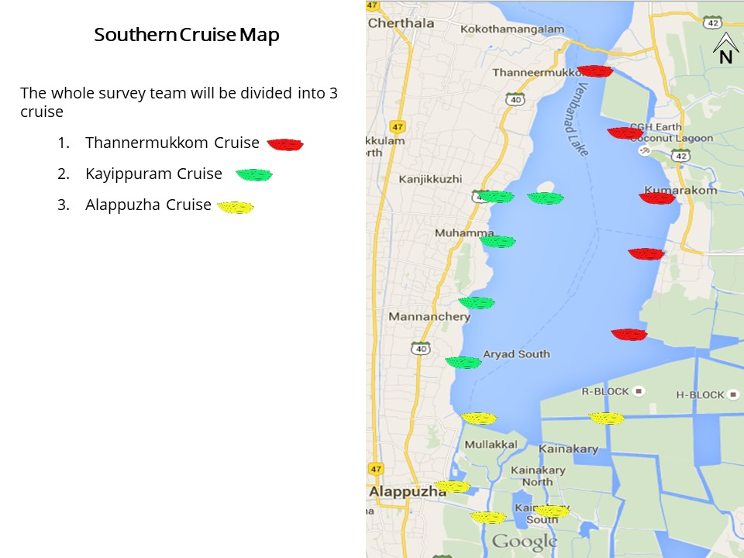

Fig 1: Cruise Map (North)
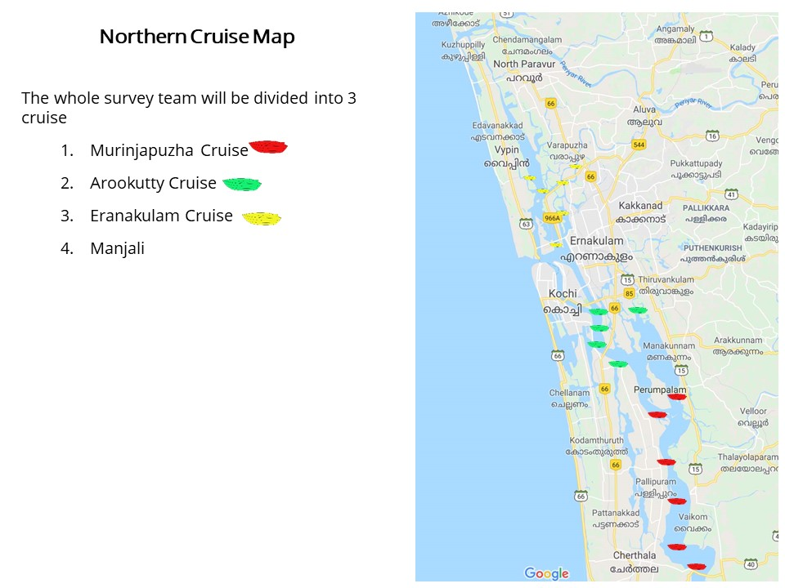

Experimental Fishing
This was facilitated with the help of local fishers who accompanied the cruise at all different stations using three major fishing gears, namely;
- Gill Net: One gill net each was laid at six locations; i.e., at two sites for each cruise. The nets were laid by around 2am and was retrieved by 6am. The collection was ice preserved till each team arrived for inspection. All entries were made on to the survey forms distributed to the participants
- Cast Net: Cast net was thrown at five points each at all five sites of each cruise (total = 5X5X3). Entries were made as mentioned above. The specimens obtained were either left back after successful identification and counting or collected in alcohol/formalin depending upon the use to be carried out later on. Alcohol preservation was preferred in case of DNA analysis and formalin in case of further morphological lab examination.
- Scoop Net: Scoop net was also carried out five times at each at all five sites of each cruise and the following activities were done as the same as above.
The abundance (number of individuals at each sampling point) and diversity (type of each species) data had been recorded on the respective survey forms provided to the participants. An additional replicate data was also collected this year in order to maintain track of the number of individuals obtained per each netting.

Inventory made from Fishers
This was carried out with the due participation of local fishers who allowed us to check the species, which contributed to their catch on the count day. Enquiries were also made on the fishing methods and socio-economic information of the fishers. The obtained informationwasrecorded to the respective survey forms.

Inventory made from Landing-centers
The major landing centers around the sampling sites viz. Punnamada, Pallom and Vaikom were visited on the two consecutive days prior to fish count and the species diversity were recorded. The type of gear used and the percentage of commercially important fishes to the catches were recorded in consultation with the fishers.

Water Quality Parameters
Water quality parameters were tested onsite as well as offsite.

Onsite:
- pH: pH is a numeric scale used to specify the acidity or basicity of an aqueous solution. pH was measured using standard pH solution marketed by C.P.R. Environmental Education Centre, Chennai (CPREC). Water samples were collected and analyzed 3 times each to arrive at concordant values. In addition, samples were also taken aboard for confirmatory lab analysis.
- Transparency: Transparency of water relates to the depth that light penetrates water. As light penetrates water, it becomes attenuated and altered in its spectral composition. The change that occurs is from predominantly yellow light at the surface to blue-green at depth in clear water or yellow-green in waters having a high concentration of dissolved organic material. Secchi disk is a simple device used to measure the transparency of water bodies. Water clarity is related to amounts of suspended particles (turbidity) as well as amounts of phytoplankton and zooplankton. Seechi readings were carried out at all sites and valued were recorded on to survey forms.
- Temperature (atmospheric/water): Temperature exerts a major influence on the biological activity and growth of aquatic organisms. Both water and atmospheric temperatures were measured at all sites using alcohol based laboratory thermometers. Results were recorded on to survey forms.
- Salinity: Salinity is the amount of dissolved salt substance of the water. Salts are compounds like sodium chloride, magnesium sulfate, potassium nitrate, and sodium bicarbonate which dissolve into ions. Salinity was measured at all sites using a salinometer and the readings were recorded on to survey forms.
Offsite: Water samples were collected in 500ml water bottles to be analyzed at Kerala State Pollution Control Board (KSPCB) affiliated labs. Water samples forestimation of dissolved oxygen was fixed in field using Winkler A and B respectively after which all samples where preserved in ice boxes.
- Total Hardness: Total hardness is defined as the sum of calcium and magnesium hardness (Even though Fe²⁺, Fe³⁺, Sr²⁺, Zn²⁺, and Mn²⁺ may contribute to water hardness, their levels are typically much less than Ca²⁺ and Mg²⁺. Their levels are not usually included in total hardness measurements) in mg/L as CaCO₃. Ideal quality water should not contain more than 80 mg/L of total hardness as CaCO3. (Vernier).
- Dissolved Oxygen (DO): Dissolved oxygen (DO) is the amount of oxygen that is present in the water. It is measured in milligrams per liter (mg/L), or the number of milligrams of oxygen dissolved in a liter of water. Samples to be analyzed was collected using Winkler method.
- Nitrate: Presence of nitrate in lakes could be from agriculture run-off waters as fertilizers are considerably made of nitrate owing to its high solubility and biodegradability. (Laue et al., 2006). Presence of normal levels of nitrates usually does not have a direct effect on aquatic organisms. Algae and other plants use nitrates as a source of food. If algae have an unlimited source of nitrates, their growth is unchecked. This could lead to “Eutrophication”, anoxia to lake conditions etc. Levels exceeding 50 mg/L (ppm) nitrate-nitrogen are considered unhealthy for lakes.
- Nitrite:Nitrites occur in water as an intermediate product in the biological breakdown of organic nitrogen, being produced either through the oxidation of ammonia or the reduction of nitrate. The presence of large quantities of nitrites is indicative of waste water pollution. Levels exceeding 0.55 mg/L (ppm) nitrite-nitrogen can cause 'brown-blood' disease in finfish.
- Iron: Concentrations above 1 mg/L will impart a foul taste to the water. High concentrations can indicate runoff from mining operations or industrial effluent and indicate the need for further investigation before prescribing a treatment regimen. Proper lake water limit levels are unavailable.
- Phosphate: High phosphate concentrations in surface waters may indicate fertilizer runoff, domestic waste discharge, or the presence of industrial effluents or detergents. If high phosphate levels persist, algae and other aquatic life will flourish, eventually decreasing the level of dissolved oxygen due to the accelerated decay of organic matter. Algae blooms are encouraged by levels of phosphate greater than 25 micrograms/L.
- Others: Magnesium, Calcium and Sulphate were the other measured parameters.

Orientation Workshop
Orientation workshop for the participants was conducted on 29th May 2019 at Karmasadhan, Alappuzha by 6 pm. Shri. Jojo T. D (Project Coordinator, ATREE-CERC) delivered the welcome address. This was followed by an orientation session by Ms. Maneeja Murali (Program Officer, ATREE-CERC) where she discussed a brief history of Vembanad and CERC’s activities, and the objectives of Vembanad Fish Count. Methodology used for data collection and the basic etiquettes and discipline/safety measures to be followed during the cruise. Participants for the program were divided into three teams for both days. For each team, a cruise leader was selected, who were assigned the task of making the organizational groups and functional groups for effective conduct of the survey. Fishing gears, resource materials and survey forms were distributed to each team before dispersing for dinner. The three designated teams for day 1 were Murinjapuzha cruise (starting from Murinjapuzha), Aroorkutty cruise (starting from Arookutty market) and High court cruise (staring from high court area). For day 2, East bank (Starting from Kumarakom), West Bank (Kayippuram) and Riverine (Starting from Alappuzha). Mr. Anu Radhakrishnan (Research Associate, ATREE-Bangalore), Ms. Maneeja Murali (Program Officer, ATREE-CERC) and Mr. Bibin Xavier (Project Assistant, ATREE-CERC) were the resource persons for all three cruises for both days.

Vembanad Fish Count – 2019 Report
On 30th May, Fish Count was flagged off by Shri. K. V. Dayal (Noted Enviromentalist), from Kayippuram jetty; the Thannermukkom and West bank cruise started from this point. The Riverine cruise started from finishing point, Alappuzha
The cruise boats moved towards each sites where the team halted for approximately 35-45mins and conducted experimental fishing with the help of different gears; viz. gill net, cast net and scoop net. Onsite water quality data and water for offsite analysis were also collected along with data pertaining to fish habitats including primary visual data. The team members of each cruise also discussed and compiled the data collected, to make a rough presentation in the concluding session.
All teams reached Ernakulam, and hated for the night from where it was continued for day 2. The collectibles and data were compiled together to provide with the necessary conclusions.

Results and Discussion
VFC 2019 reported 43, 50, and 5 fin-fishes (Annexure - 1) south of Thannermukkom bund, north of Thannermukkom bund and shell-fishes, totaling to 98 species. This count is 17 species less when compared to the post flood fish count conducted in December 2018. The reason for this large decline in species diversity could be due to Jelly-fishes, which were found in excess due to heavy salinity ranging between 16-26ppt. Improper opening closure of bunds and fewer pre-monsoon showers are to blame on this regard. Owing to this phenomenon fisherfolks are heavily affected since nettings are ineffective. Pangasius sps. a pure exotic species found more than 100kgs from wild. Need to ascertain if it is displacement or breeding in the wild. If in wild, chances of invasion to be reckoned.

Water chemistry in VFC 2019 showed huge variations in pH, Sulphate, and dissolved oxygen concentrations. pH varied between a least of 3.9 at T4 to a maximum of 7.6 at A3. However, compared to previous fish counts this is the first time we have seen a huge number of sites showing a pH below 6, precisely 18 sites, with most of the sites south of Thannermukkom bund or near to the southern part of the north section of bund. Detailed studies might be required to ascertain if the opening and closure of bund has a role to play. Dissolved oxygen percentage is considered to have 100% concentration in the upper half of column and ateast 60% at the lower half due to the hydrodynamic nature of estauries. While none of the site showed a 100, most of the sites also failed to reach a 60%. Decresing depths and over usage of houseboats alongside agricultural runoff could be the reasons. (Annexure - 2)

Suggestions
● The state and central Governments should put efforts to sustain the fisheries sector through a holistic approach which includes habitat protection, enforcement of regulations and adoption of co-management strategies. This will lead to improving the livelihoods of fishers and avoiding further degradation and deterioration of habitat quality of the ecosystem.
● Regular Fish survey and water quality analysis should be conducted during all three seasons viz. Monsoon (June-August), Post-Monsoon (October-November) and Pre-Monsoon (March-April) may be carried out for at least 3 years to make better estimation on fish diversity and ecosystem health of the lake. Long term monitoring mechanism on population dynamics of various fish species which are thought to be declining and study the effect of Thannermukkom Bund on migratory fishes Vembanad should be taken up through collaborative projects involving various research organizations.
● Develop an Index for lake conservation like Index of Biotic Integrity (IBI) forVembanad Lake ecosystem (standards for water quality and the organisms inhabiting the lake indicating ecosystem health) and regular monitoring to ensure its sustainable health.
● Awareness programs should be conducted within the community inhabiting around the lake and tourists visiting the ecosystem regarding its global importance in sustainable living and existence of all living organisms and the bigger role it could play in mitigating global climate change and ecological vulnerability if developed as a conservation model.
● Whenever wherever possible undisturbed areas of Vembanad Lake/Kole should be maintained as such to retain its pristine nature to set itself as control and scale up the health levels of the rest of the areas to a standard point possible.
● Strict pollution control policies should be developed and implemented in compliance with Wetland and Paddy Conservation Act 2008.
● A strict fishing policy should be formulated by analyzing various methods currently used in the ecosystem so that only the most sustainable ones are selected for practice in lake.
● Existing natural habitats and native vegetation like those surrounding Pathiramanal islands, the reclaimed portions of lake at Chithira and Rani Block of kayals should be declared as No Take Zones.
● Develop breeding and hatchery protocols for fishes that are used in ranching and stock enhancements.
● Measures should be taken to protect riparian and indigenous macrophytes inhabiting the lake.
● Ban monsoon flood plain fishery (Ootha piditham) when spawning individuals are largely targeted.
● stablishing a democratic-management system should be a top priority for fisheries planners in the Vembanad. This should be based on a bottom-up strategy rather than the conventional top-down schemes which have been a failure.
● Collaborations between various central and state government organizations, research institutes, universities, colleges, non-governmental organizations and cooperatives with due participation of local stake holders should be made and efficient programs for protecting the lake, its resources and the livelihoods of the fishers depending on the ecosystem should be adapted.
● Municipal drains should empty to the lake only after proper treatments and the water disposed henceforth should meet the ideal standards of estuarine lake water or freshwater system.
- Revisit India’s quarantine policies and revamp in such a manner that illegal fish or for that matter any kinds of species exotic in nature to India or that specific land area shall be strictly controlled so as to prevent any outbreak that might result in future.
- Handy books or field guides to identify already available exotics species in different landscapes of India, especially that Vembanad should be prepared so that layman could also be advised about alarming situations in systems.

Reference
● Asha, C. V, Cleetus, R. I., Suson, P. S., & Nandan, S. B. (2015). Environmental factors structuring the Fish assemblage distribution and Production potential in Vembanad estuarine system, India. International Journal of Marine Science, 5.
●Bates, Roger G. Determination of pH: theory and practice. Wiley, 1973.
●CERC ATREE. (2013). Participatory Mapping of Natural Resources in Vembanad Lake. Retrieved from www.vembanad.org
●Commission, P. (2008). Report on Visit to Vembanad Kol, Kerala, a Wetland Included Under the National Wetland Conservation and Management Programme of the Ministry of Environment and Forests. Retrieved from http://203.200.22.249:8080/jspui/handle/123456789/4074.
●Dunbar, Jeffery A (2001) Casting net NC Coastal fishing. Retrieved 25 August 2008.
●Florence, M. A. (2012). Sustainability and livelihood issues of Vembanad Ecosystem fisherfolk communities with special reference to Muhamma and Thanneermukkom villages.
●Fondriest Environmental, Inc. “Dissolved Oxygen.” Fundamentals of Environmental Measurements. 19 Nov. 2013. Web. <http://www.fondriest.com/environmental-measurements/parameters/water-quality/dissolved-oxygen/>
●Geetha, R., Chandramohankumar, N., & Mathews, L. (2007). Distribution of total reactive fluoride in sediments of Kuttanad waters. INDIAN JOURNAL OF ENVIRONMENTAL PROTECTION, 27(11), 1001.
●Hedley, M. J., Stewart, J. W. B., & Chauhan, B. (1982). Changes in inorganic and organic soil phosphorus fractions induced by cultivation practices and by laboratory incubations. Soil Science Society of America Journal, 46(5), 970-976.
●Kannan, K. (1979). Ecological and socio-economic consequences of water-control projects in the Kuttanad region of Kerala. Proceedings of the Indian Academy of Sciences Section C: Engineering Sciences, 2(4), 417–433.
●Kannan, K. P. (1979). Ecological and socio-economic consequences of water-control projects in the Kuttanad region of Kerala. Proceedings of the Indian Academy of Sciences Section C: Engineering Sciences, 2(4), 417–433.
●KrishnaKumar, K., & Dharmarajan, P. (2012). Fish and Fisheries in Vembanad Lake Consolidated Report of Vemband Fish Count 2008-2011.
●Kumar, A. B. (2006). A checklist of avifauna of the Bharathapuzha river basin, Kerala. Zoo Print, 21(8), 2350–2355.
●Kurup, B., & Harikrishnan, M. (2000). Reviving the Macrobrachium rosenbergii (de Man) fishery in Vembanad lake, India. Naga, The ICLARM Quarterly, 23(2), 4–9.
●Kurup, B. M., & Samuel, C. T. (1985). Fish and fishery resources of Vembanad Lake. Harvest and Post-Harvest Technology of Fishes. Central Institute of Fisheries Technology (CIFT) &Society of Fisheries Technologists (SOFTI), Kochi, India, 77–82.
●Kurup, B. M., Sebastian, M. J., Sankaran, T. M., & Rabindranath, P. (1993). Exploited fishery resources of the Vembanad Lake. Indian Journal of Fisheries, 40(4), 199–206.
●Laxmilatha, P., & Appukuttan, K. K. (2002). A review of the black clam (Villorita cyprinoides) fishery of the Vembanad Lake. Indian Journal of Fisheries, 49(1), 85–92.
●M.S. Swaminathan Research, F. (2007). Measures to Mitigate Agrarian Distress in Alappuzha and Kuttanad Wetland Ecosystem.
●Manorama, K. C., & Agricultural, K. (n.d.). Nature Watch.
●Mayaja, N. A., & Srinivasa, C. V. (2014). Rainfall characteristics of Pampa river basin, Kerala: A time series analysis.
●Michaud, J.P. 1991. A citizen's guide to understanding and monitoring lakes and streams. Publ. #94-149. Washington State Dept. of Ecology, Publications Office, Olympia, WA, USA (360) 407-7472. Moore, M.L. 1989.
●Murphy, B. R., & Willis, D. W. (Eds.). (1996). Fisheries techniques (2nd ed., p. 732). Bethesda, Maryland: American fisheries society.
●Narayanan, N. C. (2003). Against the grain: the political ecology of land use in a Kerala region, India.
●Narayanan, S. P., Thomas, A. P., & Sreekumar, B. (2011). Ornithofauna and its conservation in the Kuttanad wetlands, southern portion of Vembanad-Kole Ramsar site, India. Journal of Threatened Taxa, 3(4), 1663–1676.
●Padmakumar, K. G. (2003). Open water fish sanctuaries. Kerala Calling, 23(6), 34–36.
●Padmalal, D., Maya, K., Sreebha, S., & Sreeja, R. (2008). Environmental effects of river sand mining: a case from the river catchments of Vembanad lake, Southwest coast of India. Environmental Geology, 54(4), 879–889.
●Ramsar. (2002). VEMBANAD-KOL WETLAND. Retrieved from https://rsis.ramsar.org/ris/1214
●Samuel, C. T. (2014). Studies on systematic and biology of the fishes of Vemabanad lake.
●Sathyanathan, N. (2010). Overview of farming practices in the water-logged areas of Kerala, India. International Journal of Agricultural and Biological Engineering, 3(4), 28–43.
●Suseelan, C. (1987). Impact of environmental changes and human interference on the prawn fishery resources. Marine Fisheries Information Service, Technical and Extension Series, 73, 1–5.
●Unnithan, V. K., Bijoy, N. S., & Vava, C. K. (2001). Ecology and fisheries investigations in Vembanad Lake. CICFRI Bull, (107).
●Wolfgang Laue, Michael Thiemann, Erich Scheibler, Karl Wilhelm Wiegand "Nitrates and Nitrites" in Ullmann's Encyclopedia of Industrial Chemistry, 2006, Wiley-VCH, Weinheim.
http://www.alken-murray.com/

Annexure – 1 (List)

Fin-Fish Species List of VFC – 2018
South of Thannermukkom Bund | North of Thannermukkom Bund
- Ambassis ambassis | - Ambassis ambassis
- Ambassis gymnocephalus | - Anodontostoma chacunda
- Amblypharyngodon melettinus | - Arius arius
- Anabas testudineus | - Arius maculatus
- Anodontostoma chacunda | - Arius subrostratus
- Aplocheilus blochii | - Brachirus orientalis
- Aplocheilus panchax | - Butis butis
- Arius subrostratus | - Caranx sexfasciatus
- Brachirus orientalis | - Caranx sps 2
- Caranx ignobilis | - Caranx sps.
- Carinotetraodon travancoricus | - Chanos chanos
- Channa diplogramma | - Chelonodontops patoca
- Channa pseudomarulius | - Colichthys dussumieri
- Channa striata | - Congersox talabonoides
- Chelonodontops patoca | - Crenimugil seheli
- Cynogolossus macrostomus | - Cynoglossus cynoglossus
- Dawkinsia filamentosa | - Dyascinia albida
- Dayella malabarica | - Ehirava fluviatilis
- Etroplus suratensis | - Elops machnata
- Gambussia affinis | - Epinephelus
- Glossogobius giuris | - Epinephelus malabaricus
- Heteropneustes fossilis | - Epinephelus tauvina
- Horadandia britani | - Gaza minuta
- Oryzias setnai | - Gerres filamentosus
- Horbagrus brachysoma | - Gerres setifer
- Hyporamphus xanthopterus | - Grammoplite scaber
- Labeo dussumieri | - Grassostria madrasensis
- Macrognathus guentheri | - Hyporamphus limbatus
- Mystus armatus | - Johnius dussumieri
- Mystus gulio | - Lates calcarifer
- Mystus occulatus | - Liza parsia
- Neochela dadyburjori | - Liza subvirdis
- Parambassis dayi | - Lutjanus argentimaculatus
- Parambassis thomassi | - Megalops cyprinoides
- Photopectoralis bindus | - Minodactylus argentius
- Pseudetroplus maculatus | - Mugil cephalus
- Pseudosphromenus cupanus | - Nematlosa nasus
- Pseudosphromenus dayi | - Nuchequlla manuella
- Puntius amphibius | - Nuchequlla nuchalis
- Puntius parrah | - Oreochromis mossambicus
- Puntius vittatus | - Oxyurichthys microlepis
- Scatophagus argus | - Photopectoralis bindus
- Siganus javus | - Platycephalus indicus
 | - Pseudorhombus arsius
 | - Scatophagus argus
 | - Siganus canaliculatus
 | - Siganus javus
 | - Siganus sps
 | - Sillago sihama
 | - Sphrynae jello

Species recorded from the Landing Centre Pallom
PALLOM
Sl No | FIN FISHES
1 | Mystus gulio (Hamilton 1822)
2 | Channa marulius (Hamilton 1822)
3 | Pseudetroplus maculatus(Bloch 1795)
4 | Channa striata (Bloch 1793)
5 | Channa diplogramma (Day, 1865)
6 | Heteropneustes fossilis (Bloch 1794)
7 | Labeo dussumieri (Valenciennes 1842)
8 | Macrognathus guentheri (Day 1865)
9 | Systomus sarana (Hamilton 1822)
10 | Megalops cyprinoides (Broussonet 1782)
11 | Horabagrus brachysoma (Günther 1864)
12 | Mystus armatus (Day 1865)
13 | Hyporhamphus xanthopterus (Valenciennes 1847)
14 | Etroplus suratensis (Bloch 1790)
15 | Puntius filamentosus (Valenciennes 1844)

Species recorded from Vaikom Market.
Vaikom Market Survey
SL No | Species
1 | Mystus gulio (Hamilton 1822)
2 | Leiognathus equula (Forsskål 1775)
3 | Channa marulius (Hamilton 1822)
4 | Anabas testudineus (Bloch 1792)
5 | Pseudetroplus maculatus(Bloch 1795)
6 | Thryssa dussumieri (Valenciennes 1848)
7 | Gerres filamentosus Cuvier 1829
8 | Brachirus orientalis (Bloch & Schneider 1801)
9 | Terapon jarbua (Forsskål 1775)
10 | Channa striata (Bloch 1793)
11 | Heteropneustes fossilis (Bloch 1794)
12 | Saurida tumbil (Bloch 1795)
13 | Systomus sarana (Hamilton 1822)
14 | Clarias dussumieri Valenciennes 1840
15 | Puntius filamentosus (Valenciennes 1844)
16 | Macrognathus guentheri (Day 1865)
17 | Horabagrus brachysoma (Günther 1864)
18 | Mystus armatus (Day 1865)
19 | Sillago sihama (Forsskål 1775)
20 | Arius subrostratus Valenciennes 1840
21 | Nematalosa nasus (Bloch 1795)
22 | Siganus javus (Linnaeus 1766)
23 | Anodontostoma chacunda (Hamilton 1822)
24 | Megalops cyprinoides (Broussonet 1782)
25 | Labeo dussumieri (Valenciennes 1842)
26 | Elops machnata (Forsskål 1775)

Annexure – 2 (Water quality)

Sample code | E.coli/  100ml | PH at 29◦c | Total hardness as CaCo3 | Iron as FE | Sulphate as So4 | Nitrate as NO3 | Nitrate as NO2 | Phosphate as P | Calcium as Ca | Magnesium as Mg | Dissolved Oxygen | % Saturation | Salinity
A1 | Absent | 6.49 | 3200 | 1.25 | 2689.4 | 0.2 | 0.009 | BDL | 220.4 | 646.6 | 3.2 | 43.09 | 20.3
A2 | Absent | 7.13 | 3300 | 0.94 | 2766 | 0.18 | 0.012 | 0.06 | 240.5 | 658.8 | 4.5 | 60.6 | 20.3
A3 | Absent | 7.69 | 3250 | 0.7 | 2738.3 | 0.05 | 0.006 | 0.02 | 220.4 | 658.8 | 3.6 | 48.48 | 20.3
A4 | Absent | 7.56 | 3700 | 1.1 | 3074.5 | 0.23 | 0.04 | BDL | 260.5 | 744.2 | 3 | 40.4 | 24.3
A5 | Absent | 6.93 | 3200 | 1.3 | 2755.3 | 0.15 | 0.009 | BDL | 220.4 | 646.6 | 4.2 | 56.56 | 20.3
T1 | Absent | 5.71 | 2400 | 0.9 | 2087.2 | 0.15 | 0.005 | BDL | 160.3 | 488 | 4.4 | 59.25 | 16.2
T2 | Absent | 5.16 | 2450 | 0.8 | 2108.5 | 0.12 | 0.006 | BDL | 160.3 | 500.2 | 2.8 | 37.7 | 16.2
T3 | Absent | 4.78 | 2400 | 1.6 | 2110.6 | 0.14 | 0.01 | BDL | 160.3 | 488 | 3.6 | 48.48 | 16.2
T4 | Absent | 3.97 | 2150 | 1.76 | 2261.7 | 0.14 | 0.004 | BDL | 140.3 | 439.2 | 2.9 | 39.05 | 17.5
T5 | Absent | 4.6 | 1850 | 1.28 | 1606.4 | 0.14 | 0.004 | BDL | 120.2 | 378.2 | 4.7 | 63.29 | 13.6
H1 | Absent | 7.01 | 4350 | 0.46 | 3559.6 | 0.12 | 0.05 | 0.05 | 300.6 | 878.4 | 4.4 | 59.25 | 25.5
H2 | Absent | 6.86 | 3650 | 0.97 | 2927.7 | 0.41 | 0.06 | 0.13 | 240.5 | 744.2 | 4.2 | 56.56 | 24.1
H3 | Absent | 7.01 | 1800 | 0.35 | 1710.6 | 0.18 | 0.01 | 0.09 | 140.3 | 353.8 | 5.3 | 71.37 | 25.5
H4 | Absent | 7.02 | 4200 | 0.21 | 2387.2 | 0.16 | 0.04 | 0.09 | 280.6 | 854 | 5 | 67.33 | 25.5
H5 | Absent | 7.1 | 4650 | 0.86 | 3776.6 | 0.21 | 0.04 | 0.06 | 300.6 | 951.6 | 4.3 | 57.9 | 26.8
H6 | Absent | 7.05 | 4500 | 0.64 | 3674.5 | 0.43 | 0.09 | 0.06 | 280.6 | 927.2 | 4.4 | 59.25 | 25.5
M1 | Absent | 6.71 | 2000 | 0.27 | 1740.4 | 3.1 | 0.01 | 0.08 | 140.3 | 402.6 | 4.8 | 64.64 | 14.6
M3 | Absent | 6.91 | 340 | 0.17 | 327.7 | 1.8 | 0.01 | 0.07 | 24.05 | 68.3 | 4.5 | 60.6 | 5.2
M4 | Absent | 6.52 | 2250 | 1.34 | 1944.7 | 0.19 | 0.004 | 0.02 | 140.3 | 463.6 | DD |  | 14.6
M5 | Absent | 5.88 | 2450 | 0.87 | 2065.6 | 0.18 | 0.006 | 0.02 | 160.3 | 500.2 | 5.1 | 68.68 | 14.6
M6 | Absent | 5.97 | 2400 | 0.7 | 2397.9 | 0.16 | 0.009 | 0.02 | 160.3 | 488 | 5 | 67.33 | 14.6
R1 | Absent | 5.76 | 1850 | 0.76 | 1557.4 | 0.47 | 0.01 | 0.01 | 120.2 | 378.2 | 3 | 40.4 | 12
R2 | Absent | 5.75 | 1550 | 0.6 | 1266 | 0.55 | 0.009 | BDL | 100.2 | 317.2 | 4 | 53.86 | 12
R3 | Absent | 5.73 | 1450 | 0.93 | 1212.8 | 0.49 | 0.005 | 0.02 | 100.2 | 292.8 | 4.1 | 55.21 | 11.9
R4 | Absent | 5.77 | 1400 | 0.34 | 1153.2 | 0.83 | 0.005 | 0.03 | 100.2 | 280.6 | 4 | 53.86 | 11.9
R5 | Absent | 5.76 | 1400 | 0.26 | 1155.3 | 0.35 | 0.004 | BDL | 100.2 | 280.6 | DD |  | 11.9
R6 | Absent | 4.77 | 1850 | 1.07 | 1585.1 | 0.32 | 0.003 | BDL | 120.2 | 378.2 | 4 | 53.86 | 12
W1 | Absent | 5.76 | 2450 | 0.33 | 2200 | 0.28 | 0.003 | 0.02 | 160.3 | 500.2 | 3.9 | 52.52 | 16.1
W2 | Absent | 5.61 | 2550 | 0.92 | 2193.6 | 0.35 | 0.006 | 0.006 | 160.3 | 524.6 | 3.7 | 49.82 | 16.1
W3 | Absent | 5.63 | 2600 | 1.38 | 1776.6 | 0.27 | 0.005 | 0.01 | 160.3 | 536.8 | 4 | 53.86 | 16.1
W4 | Absent | 5.62 | 2150 | 0.71 | 1782.2 | 0.37 | 0.004 | 0.008 | 140.3 | 439.2 | 4.1 | 55.21 | 14.6
W5 | Absent | 5.65 | 2150 | 0.87 | 2057.4 | 0.38 | 0.006 | BDL | 140.3 | 439.2 | 4 | 53.86 | 14.6
W6 | Absent | 5.68 | 2500 | 0.33 | 2029.8 | 0.16 | 0.003 | BDL | 160.3 | 512.4 | 5.5 | 74.06 | 16.1

Legend for Sites mentioned above:
W3: West 3
W4: West 4
W5: West 5
W6: West 6
R1: Riverine 1
R2: Riverine 2
R3: Riverine 3
R4: Riverine 4
R5: Riverine 5
R6: Riverine 6
M2: Murinjapuzha 2
M3: Murinjapuzha 3
M4: Murinjapuzha 4
M5: Murinjapuzha 5
M6: Murinjapuzha 6
T1: Thannermukkom 1
T2: Thannermukkom 2
T3: Thannermukkom 3
T4: Thannermukkom 4
T5: Thannermukkom 5
W1: West 1
W2: West 2

A1: Arookutty 1
A2: Arookutty 2
A3: Arookutty 3
A4: Arookutty 4
A5: Arookutty 5
H1: Highcourt 1
H2: Highcourt 2
H3: Highcourt 3
H4: Highcourt 4
H5: Highcourt 5
H6: Highcourt 6
M1: Murinjapuzha 1

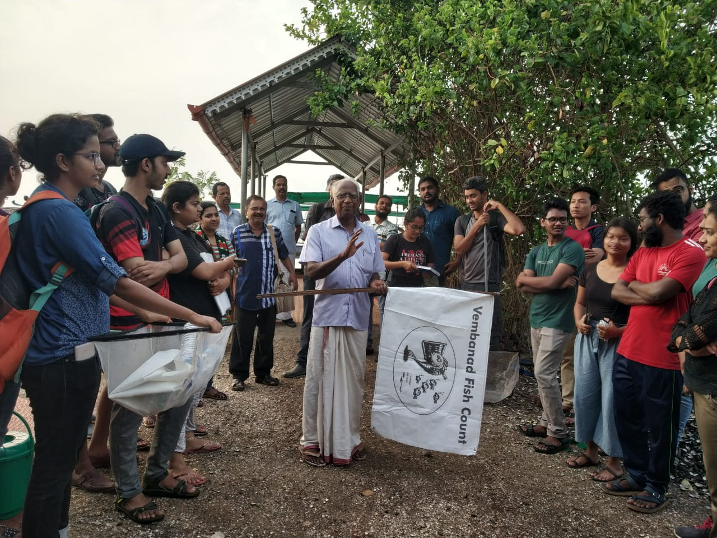
Annexure – 3 (Photos)

Vembanad Fish Count 2019 flag off

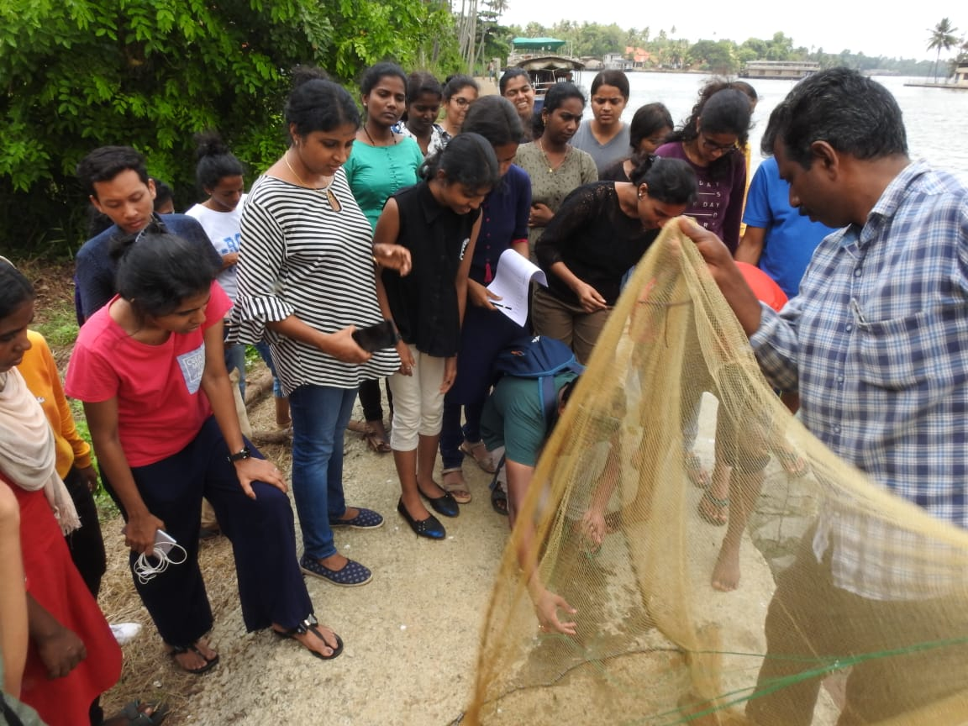

Volunteers in action

